**GLASSHOUSE CROP RESEARCH INSTITUTE TRUST TRAVEL FUND REPORT**

**2016 International-Society of Molecular Plant-Microbe Interactions XVII Congress**

**Dr. Charlotte Nellist**

**NIAB-East Malling Research**

The 2016 International-Society Molecular Plant-Microbe Interactions (IS-MPMI) XVII Congress was held in Portland, Oregon, USA. The congress was held in the Oregon Convention Centre, not far from Downtown Portland, over five days, from Sunday 17th to Thursday 21st July 2016. Over 950 delegates from 40 countries attended the congress. The congress began on the Sunday with concurrent Special Sessions, there were a total of 31 Special Session talks focusing on a range of topics from ‘Recent Advances in *Agrobacterium* Biology’ to more computational aspects, such as ‘Bioinformatics’. I decided to go to sessions on ‘Rice and Pathogen Interactions’ and ‘Molecular Dissection of Wheat Diseases’ as these were the most related to my research interests in understanding the molecular basis of plant-pathogen interactions to improve disease resistance in the cultivated strawberry.

A Welcome Reception was held at the end of the first day, outside on the Convention Centre Plaza. A buffet style meal was served from multiple stations along with locally brewed beer. This was a great opportunity to network, meet new people and also catch up with old colleagues and acquaintances, to discuss new developments in the field, as well as potential collaborations.

Concurrent Sessions were intermixed with 26 Plenary Sessions. A total of 128 concurrent talks were split over the eight sets of three Concurrent Sessions and covered a vast range of research. It was extremely difficult to decide between sessions and undoubtedly I missed many useful talks, but it also meant I was able to be selective about which sessions I wanted to focus on. I enjoyed listening to the diverse and fascinating developments in the concurrent sessions, I specifically enjoyed the updates in the sessions on ‘Recognition in Plant Immunity’, ‘Manipulation of the Host’ and ‘Apoplastic Interactions’, all of which have provided ‘food for thought’ and given me numerous ideas to develop my current and future research projects on improving disease resistance in horticulture crops.

There were many posters and talks concentrating on the plant pathogen genera, *Phytophthora*, it was inspiring to hear about the success other groups in the wider community are having in understanding the biology of various crop pathogens and the progress they are making in translating this into usable resources to provide durable resistance to this economically important genera of crop pathogens. I especially found Vivianne Vleeshouwers recent advances in understanding resistance in Potato to the model organism, *Phytophthora infestans*, the causal agent of Potato Late Blight disease completely captivating. Her work highlights the need to combine different types of resistance genes to ensure the provision of durable disease resistance. It was also thought-provoking to hear about developments in fields outside my current research interests, for example, the talk by Ken Shirasu about the molecular mechanisms of parasitic plants was really interesting.

A total of 722 posters were presented over the four poster sessions and I had the opportunity to present a poster detailing our group’s research on Strawberry – *Phytophthora cactorum* interactions during one of the poster sessions. The poster described the multiple quantitative trait loci (QTL) we have identified in response to crown rot disease (*Phytophthora cactorum*) of strawberry and also some of the advances we are making in understanding the diversity and pathogenicity of *P. cactorum*. The poster sessions were a great success as I had multiple people interested in my work. I talked to people from as far as the U.S and China, where strawberry is an important crop. When I wasn’t manning my poster I had the opportunity to view and speak to other people, there were a couple of other posters focusing on strawberry diseases. One in particular, focused on Fusarium wilt of strawberry, caused by the pathogen *Fusarium oxysporum* f. sp. *fragariae* (Fof). The presenter, Peter Henry, from the University of California at Davis, is looking to investigate and identify important genes for pathogenicity, to understand evolutionary relationships between strains from California and ultimately see if these indicate broader differences in infection strategies. It is extremely important to understand the pathogen, if you want to provide durable disease resistance.

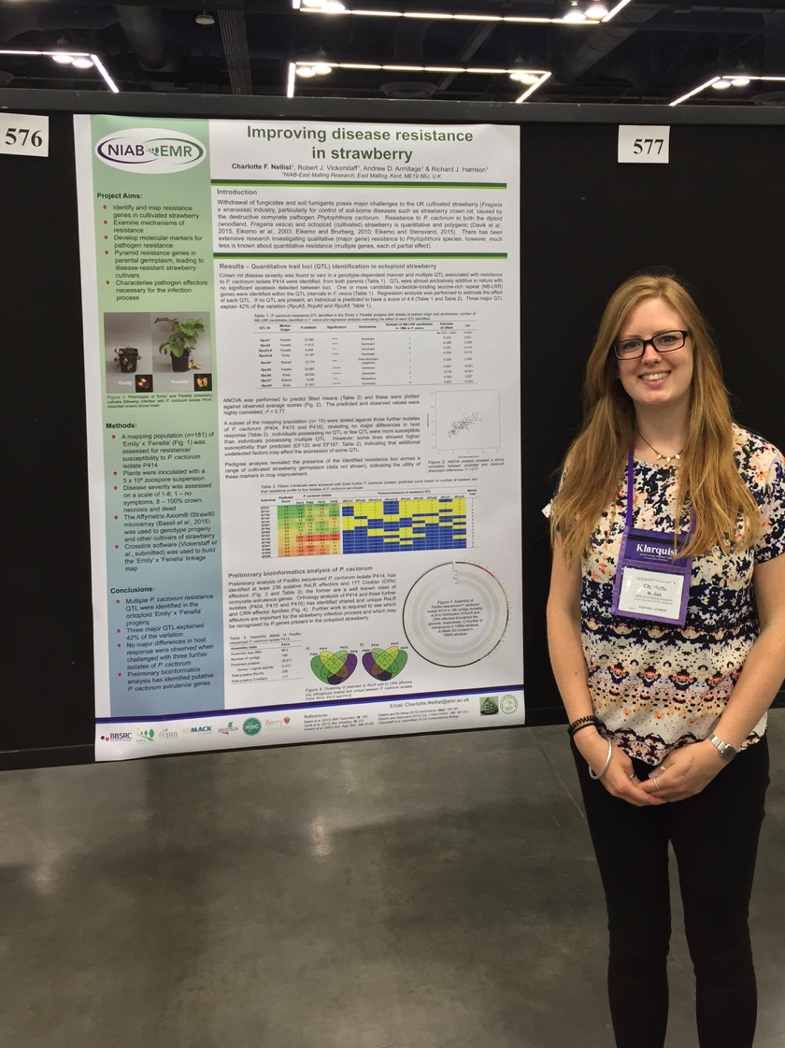

As an early career scientist, attending MPMI 2016 was extremely rewarding, not only were we exposed to exciting recent discoveries in the field, but also to timeless advice from more experienced scientists. One personal highlight of the conference was listening to the IS-MPMI 2016 awardee Sharon Long talk about her extensive career and about some of the most influential and prominent people along the way. Sharon shared a lot of valuable advice throughout her talk, in particular I found the way in which she postulates and designs experiments very useful. Causing me to reflect upon my own approach and think about applying her methods of “is it a yes/no question?” This ensures the question is more testable. Also to ask, “whether knowing the answer to this question will change what you do next?” If not, then it is not the right question. She also highlighted the need to do experiments blind to avoid bias from affecting your results and also advised not to narrow down your options too quickly and consider all possibilities.

The conference highlighted the need for the UK horticulture industry to embrace the genomics and bioinformatics revolution to help provide durable resistance to economically important pathogens. It’s really important to thoroughly understand the genome of the crop, including the repertoire of host resistance genes available in germplasm and wild relatives as well as also exploring the genomes of the pathogen and understanding the arsenal of virulence genes available in the populations. Embracing new technologies, such as CRISPR-Cas, as tools to investigate the interactions between host and pathogen will enable the implementation of durable resistance and ensure the UK horticulture industry can supply top quality produce in the face of increasing pressures to reduce chemical controls and reduce costs.

I would like to express my gratitude to the Glasshouse Crop Research Institute Trust and the British Society for Plant Pathologists for the generous financial support I received to attend this worthwhile congress and enabling me to discuss my research with the wider community. I look forward to the next meeting in Glasgow in 2019.