Travel Report for the GCRI
Bethan Shaw

9th International Conference on Integrated Fruit Production
September 4-8, 2016, Thessaloniki, Greece


The process of commercial fruit production has many issues associated with it and high pressures caused by pest and pathogen losses. With increasing need to feed an expanding population, growers are searching for methods to increase yields, reduce crop losses and incorporate integrated pest management programs into fruit growing while facing rising costs of production.

The ninth International Conference on Integrated Fruit Production was held on September 4-8, 2016 in Thessaloniki, Greece. The Integrated fruit production conference is held every 4 years and is a platform from which global research on pest and pathogen biology and control is broadcast. The 9th International Organisation for Biological Control (IOBC-WPRS) Working Group on Integrated Protection of Fruit (IFO) was divided into subgroups: "Soft fruits", "Pome fruit arthropods", "IFP Guidelines", "Pome fruit diseases" and "Stone fruits”. The conference is the largest event held by the IOBC working group. The conference was attended by over 120 people from 20 countries across the world including Europe, Africa, USA and New Zealand. Many of the delegates were research leaders but it was noted during the conference that there was a high number of postgraduate and PhD students.

There were 53 posters and 70 oral presentations including key note speakers throughout the conference on all subgroup topics. The 3 days were divided into 11 sections within the subgroups with parallel oral and poster session occurring simultaneously for entomology and pathology. The topics covered: semiochemicals in IFP, Moths, Disease of Soft Fruit, Fruit Flies, Disease of Pome Fruit, Disease and Pest Warning Systems, Brown Marmorated Stick Bug, Sucking Insects, Disease of Stone Fruits, Biological Control of Mites and Insects and Spotted Wing Drosophila (Drosophila suzukii, D. suzukii).

For D. suzukii a whole day was dedicated to communicating global research in 17 oral presentations and 9 posters: one of which displayed the results of my first year of my PhD.

The D. suzukii day displayed how important this pest has become globally over the past 10 years and also how much is still unknown. Several oral and poster presentations were dedicated to investigating the use of parasitiods and predators to control the pest within the crop. As predators play a vital role in integrated pest management (IPM) approaches, many researchers are exploring what naturally occurring predators and parasitoids are able to predate on D. suzukii. Although in Asia, where this pest is native, there are several species that are effective at reducing population size, so far no one species has had a great impact on its own in research from Europe and the USA. The most promising results were presented by Ms S. Wolf in a poster of her PhD results in which she found a reduction in D. suzukii emergence by 46% when pupa were offered to Vrestovia fidenas, which is a native parasitiod in Switzerland.

Many speakers communicated personal interactions with D. suzukii in their countries including Poland, Sweden, Italy and the UK. In all talks there was a variation in experiences. What was clear was that even within the same region, growers were experiencing varying levels of infestation and yield loss which was accredited to a combination in differences in approaches to crop hygiene, spray programs, what crops were grown in the vicinity and what other control methods were in place.

Two interesting talks were given on the use of molecular approaches to analyses the gut content of wild caught D. suzukii adults to identify what they were feeding on. Dr M. Fountain specifically looked at the winter morph of D. suzukii to identify what resources they were exploiting during the colder months where commercial crops were unavailable. Several species were identified over two winters and it was highlighted that although there were similarities between the two years there were differences which may be due to the opportunistic feeding of polyphagous D. suzukii. Many of the species identified were species of bacteria and fungi that were involved in the decomposition or degrading of organic matter within the leaf litter of a woodland floor.

Using exclusion netting as a control method was discussed by several European research groups and had been very effective when used over individual plants, rows or the whole cropping site. Growers in Italy are subsidised by government funding to use exclusion netting which is an expensive control measure but is an economically viable option in regions that experienced losses up to 80%. E. Del Fava of Bocconi University presented data in which the cost of netting use was evaluated in relation to the potential revenues. In a budget impact analysis assay it was calculated using netting would reduce potential revenue loss to 4.5%. However as Italian growers are subsidised and crop losses in the UK are not as sever, this figure would be higher if used as a control method in UK commercial systems.

From the other entomology topics discussed at this conference it is clear that there are ‘upcoming’ pests which the UK has not yet been exposed to including the Brown Marmorated Stink Bug (BMSB) and the Mediterranean fruit fly. The BMSB research focused on understanding the life cycle of the pest in Italy and uncovered that two generations a year occurred. Unfortunately broad spectrum insecticides are used to control BMSB but this has interfered with biological control measures used to target pest mite species, aphid and scale insects. Optimising the commercially available traps as an alternative method of control resulted in the re-introduction of ‘IPM friendly management practices’. With the Mediterranean fruit fly growers are facing the same problems encountered with D. suzukii in that there are very few methods to control the pest and chemical control interferes with IPM practises. Understanding the life cycle of this pest holds the key to targeting control. Population peaks were recorded that coincided with ripening of citrus trees in October and February in the Kharga oases (area) and with apple and mango ripening in June and September in Bodkholow province of Egypt. Several talks discussed codling moth and the development of sterile insect techniques which are currently being used in Canada, areas of the USA and New Zealand. Events like this provide an opportunity for researchers not only to present research but more importantly for researchers to listen, learn and collaborate.

As there was a large focus on D. suzukii research at this conference I was able to discuss many ideas surrounding my PhD project and received a good amount of feedback regarding my poster. I presented data collected in the first year of my PhD investigating the circadian rhythms of D. suzukii and how we can use these patterns in behaviours to improve pest control measures. This was my first international conference and I have developed connections with other PhD students and have established collaborations which I hope to incorporate into my PhD research.

Without the kind contribution from the GCRI I would have been unable to attend this conference and would like to thank you for financial support you have provided. Not only have I been able to display my research but I have had the opportunity to network and learn.

Thank you
Bethan Shaw

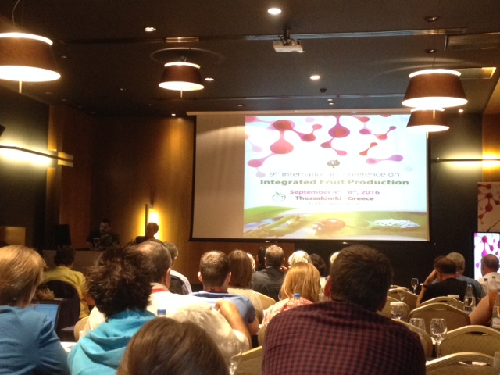
Delegates at the opening introduction to the conference

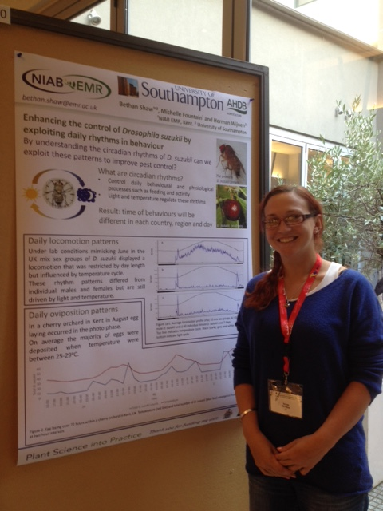
My poster at the conference discussing the use of exploiting circadian rhythms to improve pest control of D. suzukii.
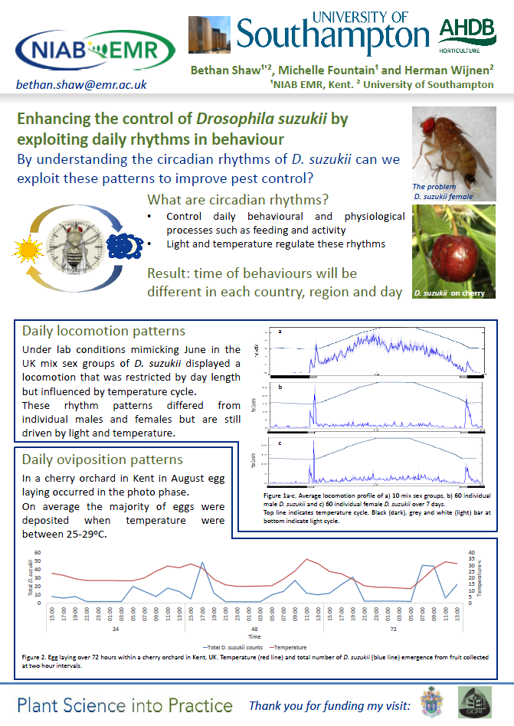
The poster I presented.

