**Report to the GCRI Trust**

**Research project to evaluate control of *Frankliniella occidentalis* with *Metarhizium anisopliae* in crop production using an auto-dissemination system**

**By Alastair Arnold**

**Writtle College and the University of Essex**

**Project summary**

This research project was undertaken in association with the Real IPM Company (Kenya) Ltd., and Writtle College, Chelmsford, Essex (UK). The work formed a part-requirement towards my Master’s degree in Horticulture Crop Production. Practical investigative work was conducted with assistance from the Real IPM team, in greenhouses and laboratories located at Thika, Kenya, from May to August 2015 inclusive. A series of experiments aimed to evaluate potential for control of western flower thrips (*Frankliniella occidentalis*) using an auto-dissemination (AD) system. The AD method involves luring insects out from crop plants, to an ‘AD device’, where they become infected with an entomopathogenic agent. In this particular project, only the entomopathogenic fungus *Metarhizium anisopliae* strain *icipe* 69 was utilised.

Firstly, greenhouse trials were carried out to determine the potential effectiveness of two semiochemicals, namely methyl anthranilate and methyl isonicotinate, in luring western flower thrips. The importance of colour on insect capture was also evaluated at this stage. In laboratory trials, the impact on fungal spore viability for *Metarhizium anisopliae* strain *icipe* 69 when exposed to semiochemical methyl anthranilate was determined. Following this, two greenhouse-based field cage trials were conducted to evaluate the effect of AD devices loaded with *Metarhizium anisopliae* strain *icipe* 69, on western flower thrips numbers in the crop. In addition, field cage trials sought to determine whether fungal spores could be detected on insects retrieved from crop plants and if insects would succumb to fungal infection following surface sterilisation and incubation. A further trial, carried out within an active cut flower production greenhouse in Thika, set out to evaluate whether installation of AD devices would impact on incidence of western flower thrips and levels of associated damage within the crop.

**Background and previous work**

Since its rapid global spread dating from the early 1980s onwards, the western flower thrips has proven extremely problematic to growers and effective control has been very difficult to achieve. Western flower thrips displays thigmotactic behaviour, minimising the usefulness of sprays, which often require contact with insects in order to work. It proves a highly damaging polyphagous insect pest and acts as a virus vector for numerous harmful plant viruses, more notably impatiens necrotic spot virus (INSV) and tomato spotted wilt virus (TSWV). The western flower thrips has developed resistance to many of the chemical insecticides currently utilised for its control. Issues such as the ineffectiveness of chemical insecticides and raised consciousness surrounding the environmental impact of their heavy use, are driving the requirement for development of alternative crop management approaches.

Entomopathogenic fungus *Metarhizium anisopliae* (Metschn.), classified within phylum Ascomycota and order Hypocreales, was first isolated in Russia in 1869 and has since demonstrated activity against a range of insect pests. Extensive work has shown the fungus to be safe to humans and the environment, when used as an agent of biological control. Starting in the mid-1990s, research work [largely carried out at the International Centre of Insect Physiology and Ecology (*icipe*) in Nairobi, Kenya], has demonstrated that effective control of western flower thrips can be achieved through use of *Metarhizium anisopliae*. Successful infection will typically result in insect death within three to five days. Earlier work achieved control largely through means of spray applications. More recently, however, there has been increased interest in development of alternative methods, such as AD device-based control systems. One major reason for this is that spores of *Metarhizium anisopliae* are highly sensitive to environmental factors such as UV sunlight and will typically demonstrate a short life of just a few days on crop foliage. When protected within a physical AD device structure, fungal spore viability levels can be potentially maintained for a longer time period.

Laboratory trials at *icipe* have highlighted *Metarhizium anisopliae* strain *icipe* 69 as being particularly effective against western flower thrips when compared to other strains within the species. In addition, *icipe* field cage studies have indicated that this strain could be used within an AD system for effective control of western flower thrips. Research has shown that semiochemicals such as methyl anthranilate and methyl isonicotinate can increase the number of western flower thrips caught on trapping materials, or visiting an AD device. The present research project aimed to complement the previous work of organisations such as *icipe* and during the formative stages of the project a meeting was conducted with Dr Sevgan Subramanian, the head of ‘Thrips in IPM Vegetable Ecosystem Programme’ at *icipe*. The present research project tested a new design of AD device, exclusively developed by Real IPM (Kenya) Ltd. for use in innovative integrated pest management programmes.

**Main findings**

In every trial where colour was compared, blue colouration significantly (P<0.05) increased numbers of western flower thrips visiting trapping materials compared with yellow. On average across the trials, 70% were attracted to blue and 30% to yellow. This observation confirms the findings of many previous studies. Semiochemical methyl anthranilate did not affect numbers of western flower thrips visiting trapping materials in any of the trials where tested. Previous work on methyl anthranilate with relation to thrips capture is very limited, however it is known to increase attractiveness for some thrips species and this response is likely species specific. The present research project showed that this semiochemical has no effect on numbers of western flower thrips visiting trapping materials in greenhouses in Kenya. In contrast, semiochemical methyl isonicotinate significantly (P<0.05) increased numbers of western flower thrips visiting trapping materials in four of five trials. This finding is strongly supported by previous studies on the same.

Exposure to methyl anthranilate under controlled conditions had no detrimental effect upon fungal spore viability for *Metarhizium anisopliae* strain *icipe* 69 at concentrations weaker than 1:10 semiochemical in solution. There were slight indications of a negative impact where concentration of methyl anthranilate exceeded 1:10, however, additional testing would be required to further determine this. This observation complements the (unpublished) indications from *icipe*, which state methyl anthranilate to be ‘compatible’ with entomopathogenic fungus *Metarhizium anisopliae*. It is not thought that to date any widely available published work has sought to determine this.

Based upon findings from the earlier colour and semiochemical testing trials and to maximise attractiveness to western flower thrips, it was decided to line the exterior of AD devices with blue trapping material (Plate 1). This material was given a clear, non-stick finish. In the first field cage trial in which no semiochemical lure was used, addition of *Metarhizium anisopliae* strain *icipe* 69 into AD devices had no effect upon numbers of western flower thrips on crop plants compared to control. Spores were detected on bodies of western flower thrips extracted from crop plants after two weeks of trial duration on specimens originating from three of the six ‘treatment’ field cages. Subsequent colony growth of *Metarhizium anisopliae* strain *icipe* 69 was observed from insect wash solutions originating from these three field cages (Plate 2). Similarly, growth of *Metarhizium anisopliae* strain *icipe* 69 was observed following surface sterilisation and incubation on western flower thrips specimens collected from the same three field cages (Plate 3).

In the second field cage trial, in which semiochemical methyl isonicotinate was used as lure, addition of *Metarhizium anisopliae* strain *icipe* 69 into AD devices significantly (P<0.05) reduced numbers of western flower thrips on crop plants compared to control after two weeks trial duration (Figure 1). This finding fits well with the observations in earlier trials that methyl isonicotinate increases numbers of western flower thrips visiting trapping materials and further corroborates the work of other authors. In contrast to the first field cage trial,

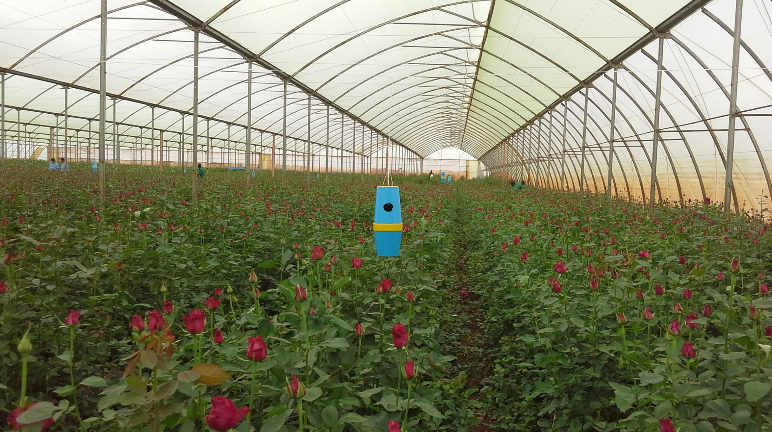

Plate 1. The AD device developed for application in thrips control. Blue colouration is from band trapping material.

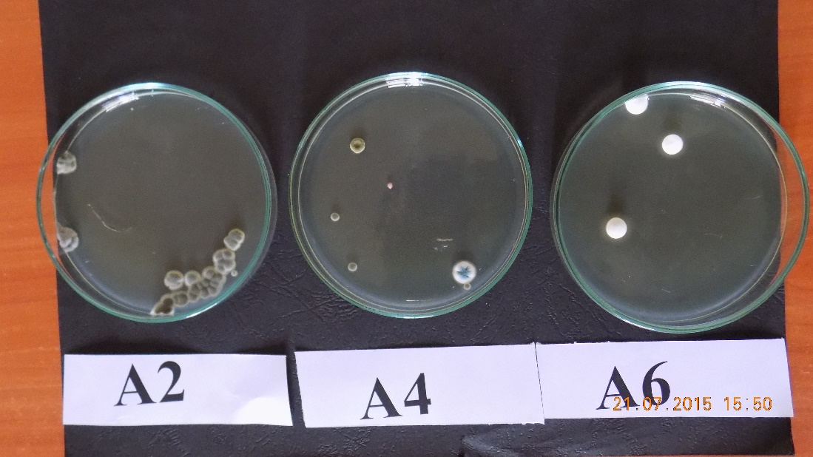

Plate 2. Growth of fungal colonies on PDA plates containing wash solution of western flower thrips from ‘treatment’ field cages. Labels refer to the block and cage number of sample origin.

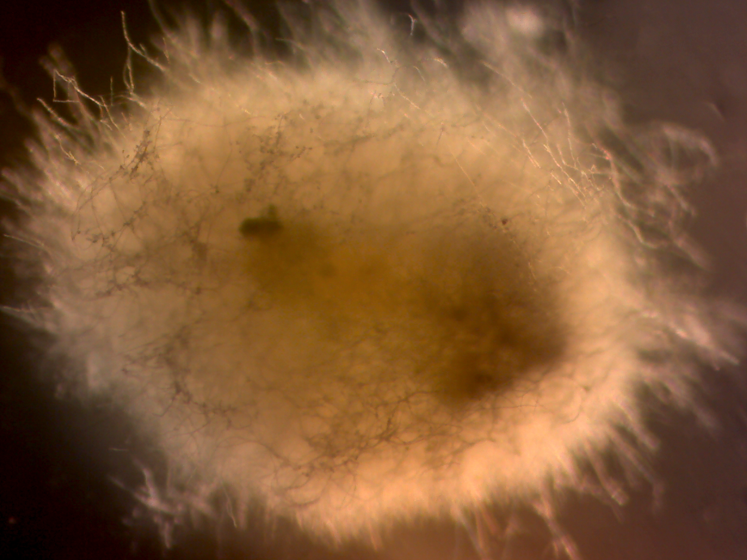

Plate 3. Microscope photograph showing growth of *Metarhizium anisopliae* strain *icipe* 69 on western flower thrips specimen from field cage A4. This specimen had been surface sterilised and then placed into incubation at 25˚C. Scale not given.

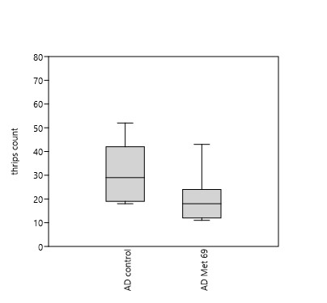

Figure 1. Western flower thrips count on crop plants in Block G of field cage trial two, after two weeks (n=9). Treatment ‘AD Met 69’ featured *Metarhizium anisopliae* strain *icipe* 69 in AD devices, whereas ‘AD control’ did not.

spores were detected on western flower thrips specimens from all six ‘treatment’ field cages after just one week’s trial duration. Subsequent colony growth of *Metarhizium anisopliae* strain *icipe* 69 was observed from insect wash solutions originating from all of these field cages. Growth of *Metarhizium anisopliae* strain *icipe* 69 was observed following surface sterilisation and incubation on western flower thrips specimens collected from all six ‘treatment’ field cages, after both one and two weeks trial duration. All results from the field cage trials indicate that inclusion of an effective semiochemical lure is likely essential for successful development of AD device-based control systems for western flower thrips.

Installation of AD devices into the active cut flower production greenhouse appeared to have minimal impact on levels of western flower thrips and their associated damage. However, there were no major pest outbreaks through areas into which the AD devices were installed and both incidence of damage and insect counts had been reduced after one month of trial duration. In light of results from the field cage trials, the omission of a semiochemical lure in the cut flower greenhouse trial might have minimised its impact. This trial is ongoing and it is planned to introduce a lure to the installed AD devices in the near future. Percent viability of fungal conidia in AD devices was measured throughout this trial. A relative reduction of 54% in viability was observed through the first three weeks. This decrease is slightly less than that recorded during the field cage trials, which showed a relative reduction of 65% fungal viability over a two week period. Relative reductions in percent fungal viability observed in this research project appear to be slightly greater than those reported by other authors in similar work.

The findings from this research project may prove useful in the context of future development of IPM programmes for control of western flower thrips. In particular, the methodologies developed and tested in the field cage trials, could be applied to larger, field-scale trials that thoroughly test effectiveness of AD device-based control systems. For application in horticultural crop production, AD systems will need to be carefully integrated with the use of compatible predatory insects and possibly chemicals, in balanced programmes that target different lifecycle stages of western flower thrips.

**Acknowledgements**

I would especially like to thank Dr Henry Wainwright and Louise Labuschagne at the Real IPM Company (Kenya) for supporting this research project. A special thank you must also be extended to Daniel Nene, Kenneth Ngeno and Judith Ongili at the Real IPM Company (Kenya), for extensive daily help with practical work and organisation. At Writtle College, I would like to thank Dr Chris Bishop and Dr Anya Perera for providing authoritative guidance and helping with project planning. I am also grateful to the GCRI Trust, who funded my travel to Kenya to undertake this research project. The GCRI Trust promotes scientific research and education on cultivation of protected and field grown crops and provides travel grants to researchers, managers and practitioners involved in British horticulture.

**Selected sources consulted**

Broughton, S., Cousins, D. and Rahman, T. (2015) Evaluation of semiochemicals for their potential application in mass trapping of *Frankliniella occidentalis* (Pergande) in roses. *Crop Protection* [online]. **67**, p130-135. Available from World Wide Web.

Maniania, N., Ekesi, S., Löhr, B. and Mwangi, F. (2001) ‘Prospects for biological control of the western flower thrips, *Frankliniella occidentalis*, with the entomopathogenic fungus *Metarhizium anisopliae*, on chrysanthemum’. *Mycopathologica* [online]. **155**, p 229-235. Available from World Wide Web.

Mfuti, D., Subramanian, S., van Tol, R., Wiegers, G., de Kogel, W., Niassy, S, du Pleiss, H, Ekesi, S. and Maniania, N. (2015) Spatial separation of semiochemical Lurem-TR and entomopathogenic fungi to enhance their compatibility and infectivity in an autoinoculation system for thrips management. *Pest Management Science* [online]. Available from World Wide Web.

Niassy, S., Maniania, N., Subramanian, S., Gitonga, L. and Ekesi, S. (2012) Performance of a semiochemical-baited autoinoculation device treated with *Metarhizium anisopliae* for control of *Frankliniella occidentalis* on French bean crops. *Entomologia Experimentalis et Applicata* [online]. **142**, p 97-103. Available from World Wide Web.

Niassy, S., Maniania, N., Subramanian, S., Gitonga, L., Mburu, D., Masiga, D. and Ekesi, S. (2012) Selection of promising fungal biological control agent of the western flower thrips *Frankliniella occidentalis*. *Letters of Applied Microbiology* [online]. **54** (6), p 487-493. Available from World Wide Web.

Teulon, D., Casta $\tilde{n}$ e, C., Nielsen, M., El-Sayed, A., Davidson, M., Gardner-Gee, R., Poulton, J., Kean, A., Hall, C., Butler, R., Sansom, C., Suckling, D. and Perry, N. (2014) Evaluation of new volatile compounds as lures for western flower thrips and onion thrips in New Zealand and Spain. *New Zealand Plant Protection* [online]. **67**, p 175-183. Available from World Wide Web.