**BRIEF TECHNICAL REPORT FOR THE GCRI TRUST**

**Antonio Llorente**, **PhD Student East Malling Research**

*Study Tour and Collaborative International Experimentation in Málaga, Spain*

I must start by thanking the GCRI trust for its financial assistance for the travel and subsidence during my time in Málaga. The trip lasted from the 16th to the 29th of April 2015, was very productive and a great experience.

Malaga University (UMA) is a public university with more than 39,000 students and 2,400 lecturers. It well known by their Science Departments particularly the Biochemistry Department. Prof Valpuesta is part of it, his lectures and research take place mostly at the campus of this university. His work has an eminent molecular approach having interest in abiotic stresses and strawberry fruit quality. His support was a valuable opportunity to add molecular training to the physiology expertise I am gradually gaining under the supervision of Dr Mark Else at East Malling Research.

Prof. Valpuesta offered me the chance to advance on the study of my research hypothesis with three unique in the world transgenic strawberry lines which have a reduced ethylene perception by down regulation of the FaETR1 gene. In return he is expecting a joint publication to come from the findings. Ethylene may be involved in the increase of fruit quality, particularly phenolics, observed in the fruit of water deficit stressed strawberry plants. When irrigation is withheld long enough to let the plant wilt there is an increase in ethylene production rate parallel to phenolic accumulation. Using plants with diminished ethylene perception is a valuable tool to elucidate whether ethylene acts as a signal for the accumulation of phenolics. An experiment was carried out in order to test this hypothesis.

Phenolics are potent antioxidants with potential health benefits and ethylene is a gas molecule which is well known by the industry for its role in fruit ripening. If ethylene were a signal for the accumulation of phenolics in the strawberry, it might be considered as agronomic tool to increase the health properties of the strawberry fruit and add economic value.

The experiment was located in a greenhouse at the IFAPA Churriana Research Station (Málaga). This centre holds a wide experience in strawberry research and it has been a major contributor in the success of the strawberry industry in Spain. Dr Elsa Martínez Ferri was my contact there and an enthusiastic help who advised and supply me with material and instruments during my work.

The plants were propagated in October 2014, which was two months later than it should be and the weather was cold for Málaga. As a result, they suffered from an unusual development, producing late fruits and developing small canopies. The expression of the FaETR1 in transgenic lines was verified in January 2015.

Once plants were scored by size and fruit numbers, four plants per treatment were chosen. The treatments were “control well watered” (CWW), “control severe water deficit” (CSWD), “L10”, “L12”, “L15” all transgenic and SWD (five treatments in total). Substrates were irrigated to full capacity and drying down started on the 20th of April 2015. During drying a set of physiological measurements were carried out including net photosynthesis, stomatal conductance, photosystem II performance, substrate moisture, pot weights, ambient temperature, relative humidity and light intensity. On the second day of wilting, fruit and leaf samples of each plant were cut, immersed in liquid nitrogen and stored for future RT-qPCR. This analysis will be funded by Málaga University where I have to come back in June 2015. I will be measuring expression levels of genes involved in ethylene biosynthesis, perception and signalling as well as phenolic production and oxidation for which Dr Karen Merchante Berg is already providing me with the necessary training.

On the whole, this trip was a unique opportunity to round up the research for my Thesis, establishing links with other research groups and gaining training. Through my experience the UK industry will gain a better trained researcher and more knowledge which in the long term might be translated into added value for the strawberry production.

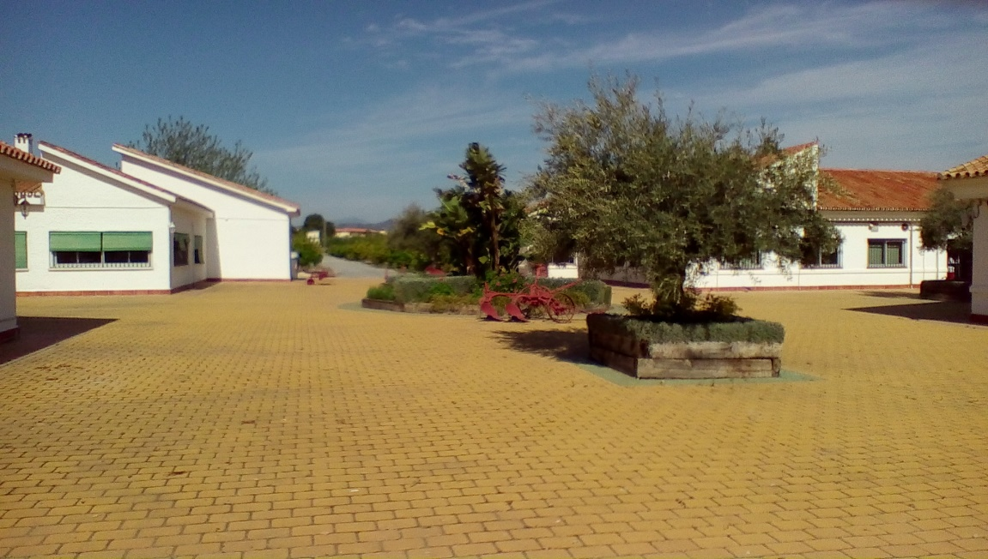

Figure . IFAPA Churriana Research Station. Central Patio with rows of orange trees on the background.

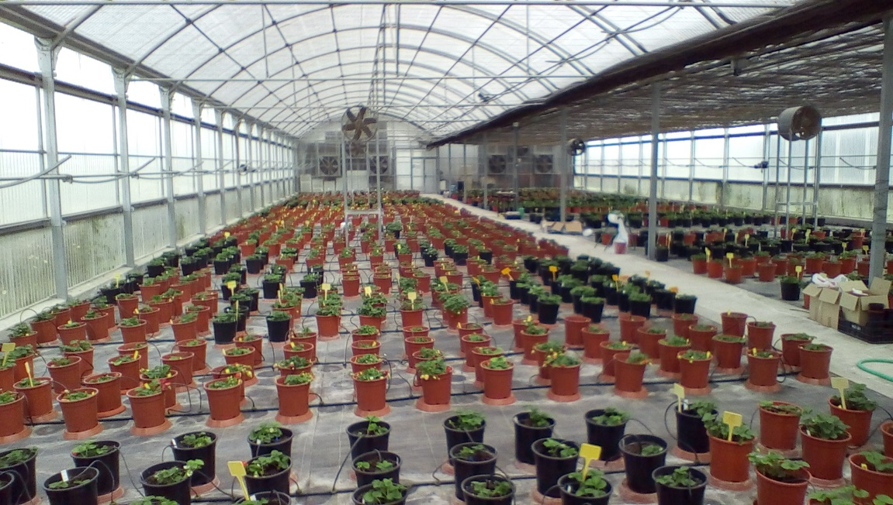

Figure . Transgenic material at IFAPA Churriana Research Station. Along the years work and experience of Prof Valpuesta team has developed this unique collection.