Travel Report for the GCRI
Louisa Robinson Boyer

The International Conference on Mycorrhiza (ICOM8)
August 3–7, 2015
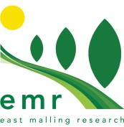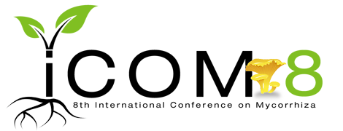

Mycorrhizal fungi integrate with plants and microorganisms to form complex communities that define ecosystems and the structure and function of soils. Mycorrhizas are well known for their role in plant health and for the production of food, although their complex interaction within the soil ecosystem is less well defined. Mycorrhizas are found globally and function at the interface between living roots and mineral soil.

The Eighth International Conference on Mycorrhiza (ICOM8) described as Mycorrhizal integration across continents & scales was held on August 3–7, 2015 in Northern Arizona University, Flagstaff, Arizona, USA. ICOM is the International Conference on Mycorrhizal fungi and is held approximately every 3 years. It is a global opportunity for the exchange of information and current research regarding these beneficial microbes. ICOM8 was attended by approximately 475 people from more than 50 countries including public and private researchers, academics, post-graduate students, inoculum producers and land managers.

There were approximately 285 posters and 140 talks, including key notes, sessions and lightening talks that took place over 5 days. These were based around 4 session themes; (i) Diversity and biogeography of mycorrhizal fungi, (ii) Linking mycorrhizal genomes, transcriptomes and proteomes to their function from individuals to ecosystems, (iii) Mycorrhizal movement of matter and energy from crossing membranes to biogeochemical cycles and (iv) Mycorrhizas and global change. On the Thursday there was a particularly interesting session which was entitled ‘strategies to manage mycorrhizas for sustainable agriculture’. In this session I presented a poster on the use of AMF to improve soft fruit production in commercial substrate growing systems. This reported on the findings of my PhD project and highlighted EMR Interreg and Innovate UK projects examining the beneficial role of microbes in soil-free substrates for strawberry production. My work was very well received and provoked many interesting discussions, involving inoculum producers, potential collaborators from the UK and Europe, and academic discussions.

The conference covered many aspects of Mycorrhizal fungi research and included a substantial element regarding the application of AMF in agriculture and horticulture. There were a number of talks and posters relevant to mycorrhizal research at EMR and for the wider fruit industry. One particularly interesting Key note lecture was given by Paola Bonfante from the University of Turin, Italy, in which she spoke about the role of AMF in plant productivity. Paola presented a thorough overview of the mechanisms that allow plants to uptake minerals and demonstrated how mycorrhizal fungi have a significant systemic impact on crop plants in many situations. Guido Lingua from the Università del Piemonte Orientale, Italy also gave a very informative poster describing his work that shows AMF and PGPR to improve strawberry fruit quality, modulate elements and volatile concentrations. Inoculations enhanced root and shoot biomass and increased fruit yield and quality, with increased sugar and anthocyanin concentrations.

The interactions between AMF and other soil and root microorganism, such as endophytes, is an exciting area that was discussed by a number of researchers. Duncan Cameron from the University of Sheffield gave a very interesting talk looking at Mycorrhiza-induced pathogen resistance in Wheat. He described the enhanced plant induced defence by the addition of AMF and PGPR together. A. Desiro also talked about the interaction of AMF with endobacteria and how they can influence the AMF, and A. Estrada-Luna, presented a poster looking at the effects of AMF and root endophytes on drought tolerance of Washingtonia robusta plants. The interactions that occur between AMF and other microorganisms are currently poorly understood but may well become an interesting tool in future practice.

Improving the benefits obtained from certain soil microbes may hold the key to achieving greater value from cropping systems, as we seek to reduce fertiliser use, conserve water and increase yields. It is well documented that one major function of mycorrhizal fungi in soils is to significantly enhance phosphorus uptake. More recent work has shown that enhanced nitrogen and micro nutrient uptake is also significant, together with locking essential soil carbon in the upper soil horizons. Research to understand the value and function of mycorrhizal fungi has been a global endeavour with a contribution of more than 60,000 peer-reviewed papers and articles over the last fifty years. Moreover, far from being solely of academic interest, the use of mycorrhizal fungi and other classes of soil microbes, such as plant growth promoting rhizobacteria has become common practise in agriculture in some parts of the world, from wheat in Canada to cassava in Brazil. The use of manufactured mycorrhizal fungal inoculum in the UK is now established and a number of demonstration and extended research projects are under way.

Mycorrhizal associations are multi-functional, assisting the plants in nutrient acquisition, water uptake, mediating carbon transfer and protecting roots from pathogens. With changes in the world climate, water limitation is becoming an increasing concern for global crop productivity. Most plants benefit from the mycorrhizal symbiosis through the improvement of water status and uptake. Although most cereal and horticultural crops are good hosts, some plants are not, for example the Brassicaceae. Ericaceous plants will only form an association with a unique mycorrhizal group called the Ericoid mycorrhizas. This highly adapted mycorrhizal group functions in a similar way to support ericaceous plants in acidic soil environments. Commercially manufactured inoculum of Ericoid mycorrhiza is also now available in Europe and the UK.

Commercial fruit production is rapidly moving towards protected cropping systems in soil-free substrates where growers are facing increasing restrictions form legislation and water availability. Soil-free substrates, devoid of microbes is likely to be an area where the addition of beneficial microbes is highly advantageous. Research at EMR has shown that inoculation of strawberry in substrate with Mycorrhizal fungi increases productivity and confers a greater tolerance of drought.

It is clear from the vast research presented at ICOM8 and the work being conducted here in the UK that microbial biology has a key role in the future of sustainable cropping. Mycorrhizal fungal inoculum is produced in the UK by PlantWorks Ltd, Sittingbourne, Kent, www.rootgrow.co.uk.

I wish to thank the GCRI for their kind contribution towards my travel expenses to this conference, allowing me to represent mycorrhizal research at EMR in an international forum.

The book of abstracts for ICOM8 can be found at http://nau.edu/uploadedFiles/Centers-Institutes/Merriam-Powell/ICOM8/_Forms/Abstracts_Index_7_26.pdf.

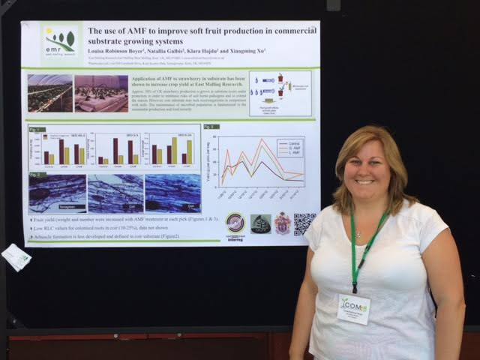
Poster session Louisa Robinson Boyer


NAU campus, Flagstaff.

