GCRI Trust Travel Grant Report 2013
International Conference on Mycorrhizal Fungi 7 (ICOM 7)
Natallia Gulbis

ICOM 7 was an international conference which brought together from different countries all working on mycorrhizal fungi. This event is held every three years and ICOM 7 took place in New Delhi from 6th to 11th January 2013. The Energy and Resources Institute proudly hosted this global forum for the interaction of researchers from the academic and applied areas in the field of mycorrhizal symbiosis (www.teriin.org/). The theme of the ICOM 7, Mycorrhiza for All: An Under Earth Revolution, focused on the latest research and development in the field, and the efforts made to promote its benefits to man kind.

Mycorrhiza is the most common underground symbiosis and is present in 92% of plant families studied (80% of species), with arbuscular mycorrhizas being the ancestral and predominant form. This relationship consists in the colonisation of plant roots by the micro-organism and the creation of a site of nutrient exchange. Plants receive mineral nutrients and in turn feed the fungus with carbohydrates. Plants from Brassicaceae family are known as non-mycorrhizal; Rhododendrns, Azaleas, Heathers, Cranberries or Blueberrues make associations with Ericoid mycorrhizas; ectomycorrhizal fungi colonise forest plants. Beneficial microorganisms associations with roots contribute to sustainable horticulture and agriculture, including protected crops. Most agricultural crops can perform better and are more productive when well-colonized by mycorrhizal fungi. Mycorrhiza helps crops: to overcome replanting problem more successfully, to cope with conditions of draught, to increase pest and disease resistance and etc. The movements towards more sustainable forms of agriculture will result in an increased use of organic sources of nutrients including crop residues, farm and urban wastes. The ability of AM fungi to utilise organic forms of N and P is likely to be a key-determining factor in the impact of these wastes on crop productivity.
Mycorrhiza, with its mutualistic and symbiotic association, is of great relevance and significance in the current scenario. Facing the stark reality of increasing demand for food production, food security and nutrient deficiency; mycorrhiza holds the key for its beneficial role owing to its contribution to the plant apropos to phosphorous nutrition in agriculture.

Genomics, nutrients exchange, ecology and mycorrhiza in agriculture and horticulture, inoculation of seedlings, inocula production and policy development were the main topics in the conference. There were plenary lecture sessions in the mornings following a poster session, and the participants had a choice of three workshops in the afternoons.

All the lectures and workshops were very interesting, but I would like to highlight few of them that particularly attracted my attention.

‘Reciprocal rewards help stabilize cooperation in the mycorrhizal symbiosis’ by Toby Kiers and Heike Buking.
Toby and Heike manipulated the extent to which plant and fungal symbionts supply nutrients to their partner to show that plants can detect, discriminate and reward the best fungal partners with more carbohydrates. In turn, their fungal partner would enforce cooperation by increasing nutrient transfer only to those roots providing more carbohydrates. The authors concluded that cooperation between partners can be stabilised in a form analogous to a market economy where there are competitive partners on both sides of the interaction and higher quality services are remunerated in both directions.

14C-photosynthate and 33P-nutrient translocation between extraradical mycelia of ectomycorrhizas via mycelial anastomosis by Bingyun Wu.
The objective of this particular research was to investigate how the mycorrhizal network connection by mycelial anastomosis functionally extends the nutrient movement. Using ¹⁴CO₂ and ³³P-phosphoric acid Binguin proved that hyphal connection was formed between the same isolate Pisolithus near the contact site. ¹⁴C and ³³P were translocated between mycelia of the same isolate, but it didn’t happen between different isolates. These results provide direct evidence that contact and hyphal connection between mycelia of the same ectomycorrhizal fungus isolate can result in an expanded extraradical mycelium network and enhanced nutrient translocation.

‘Lessons from living together in harmony from the arbuscular mycorrhizal symbiosis’ by Natalia Requena
Natalia emphasized that microorganisms are permanently challenged with hazardous environmental conditions that restrict their potential for survival and reproduction. To overcome this threat many of them evolutionary opted for a life in symbiosis. Fungi from the Glomeromycota phylum engaged in a life in mutualistic symbiosis with plants’ roots more than 450 million years ago. Arbuscular mycorrhizal fungi are obligate biotrophs and need to feed on photoassimilates during their in planta growth for the completion of their life cycle. To do that Am fungi have to first overcome the defense barriers of the host during colonisation and then use carbon resources without provoking a parasitic situation. Natalia explained the molecular mechanisms of how a plant and a fungus recognize each other to achieve an almost perfect relationship.

There was a trip to the field organised on the 9th January, so delegates could see mycorrhiza at live in action. I saw mycorrhiza in the fields along with a model sustainable habitat based on new and clean technologies. They showed us experiments with different crops growing in 3 conditions: 100% recommended dose fertilizer (RDF), mycorrhizal treatment + 75% RDF, mycorrhizal treatment + 50% RDF. The second and the third condition had the best results; plants were bigger, stronger and healthier (see picture 1 below).

A 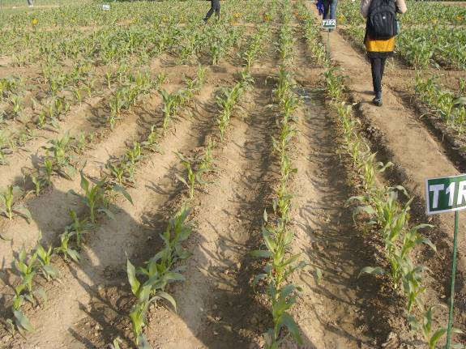 B 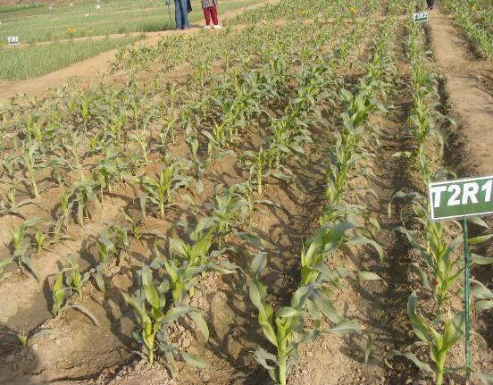 C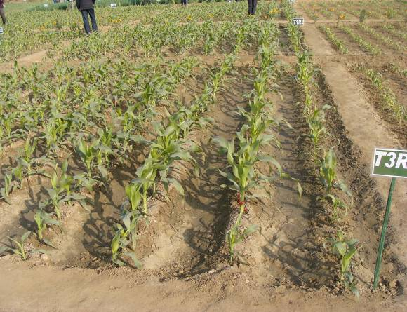
Picture 1. Different treatments of corn: A. 100% recommended dose fertilizer (RDF), B. Treatment with mycorrhizal fungi + 75% RDF, C. Treatment with mycorrhizal fungi + 50% RDF

At the conference I presented the results I have observed from the recent work carried at EMR and PlantWorks in a form of poster, which was titled “Study of Mycorrizal fungi inoculants produced in different systems on strawberry development in relation to water use and nitrogen input. Profiling and analysis of contaminations present in production systems that coexist in the final inocula”.

The conference provided an excellent opportunity to meet up with colleagues working on protected crops, and facilitated the exchange of ideas and information. I have had a number of interesting discussions with various people on different ways of production of mycorrhizal inocula and the most optimal ways of its application. The leading scientists are convinced that in vitro produced spores could be applied through irrigation system. I am very grateful to the CGRI Trust for contributing to the cost of my travel and registration fee.

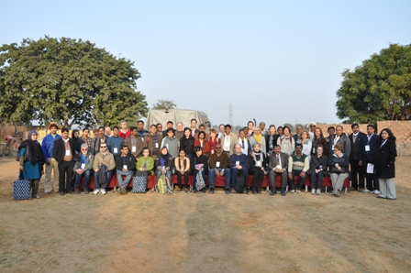
Picture 2. Participants of the field trip.

