11th International Verticillium Symposium
5th – 8th May 2013, Gottingen, Germany

Prof Xiangming Xu

East Malling Research, East Malling, West Malling, Kent, ME19 6BJ, UK
Email: xiangming.xu@emr.ac.uk Tel: +44(0)1732 523753 (Direct Dial)

The 11th International Verticillium Symposium was held in Gottingen, Germany, 5th – 8th May 2013. Over one hundred researchers from many countries (primarily European countries), but also including USA and China, attended the conference. The conference consists of invited and offered oral presentations on taxonomy & genetics, host-pathogen interaction & resistance, population genetics, and epidemiology & management. In addition, there were also two poster sessions. The conference is dominated by two research areas: rapeseed wilt caused by Verticillium longisporum and olive wilt caused by V. dahliae. The former focuses on genetics of fungal virulence, and the latter on wilt epidemiology and management. One common theme that links these two topics is that V. longisporum is believed to be an amphihaploid and one of its parental strains is V. dahliae. It is this link between the two species that Dr Dez Barbara of Warwick HRI made significant contribution to the research community. For this reason, a session on taxonomy & genetics was specifically dedicated to Dr Dez Barbara in recognition of his contribution.

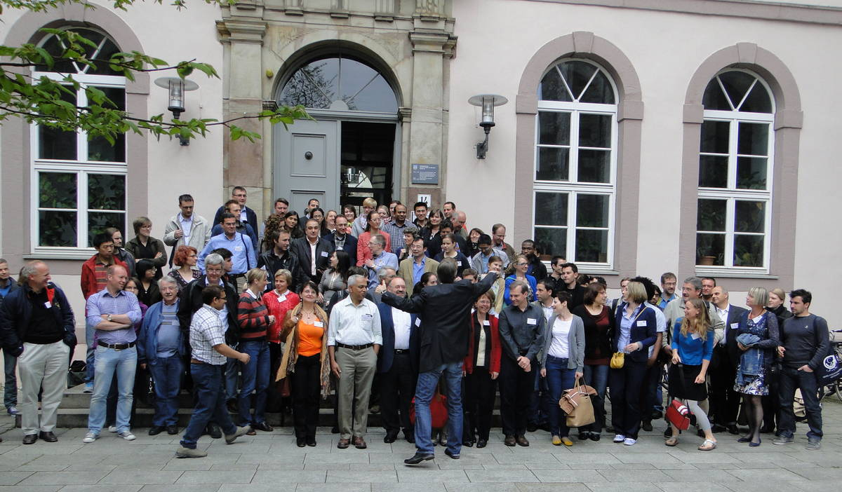

The research on V. longisporum is dominant by German researchers through a large national collaborative research project, focusing on genomics of the pathogen; many aspects of this project had been reported in the conference. V. longisporum has presented a significant challenge to German rapeseed industry over the recent years, particularly in areas with little crop rotation. In addition to rapeseed, V. longisporum may also cause considerable economic losses on cauliflowers. The most important crops that are attacked by V. dahliae in Germany are strawberry and potato. In general, the disease is severe in regions with high temperature and moisture. There are 15 optical chromosomes in V. longisporum; it appears that virulent and avirulent strains mainly differed in their chromosome structure (number and/or length). Although V. dahliae is one of parental strain of V. longisporum, it is generally difficult to recognise V. dahliae chromosome architecture in the genomic sequences of V. longisporum, indicating that extensive chromosome rearrangement may have taken place since the hybridisation event. Genomic data suggested substantial horizontal gene transfer after the initial hybridization. This general feature (virulence/avirulence difference in chromosome architecture and possible horizontal gene transfer) has also been observed in V. dahliae, reviewed by a Dutch researcher. Interestingly, results based on comparison of DNA sequences from a Spanish group indicated that recombination between strains from different VCG (vegetative compatibility group) may have taken place. In addition to V. dahliae and V. longisporum, sequencing and genomic study of V. albo-atrum (causing wilt on hops) are also currently undertaken in Slovenia.

Next step up in genetic analysis of wilt pathogens is transcriptome analysis, i.e. characterising those genes that have been transcribed into proteins during key development stages, such as germination of microsclerotia and infection. These studies are still in early days; only preliminary results were reported from several researchers in Spain, Germany and China. Several studies investigated infection process and plant defence responses using Arabidopsis. A new Dutch study suggested that Verticillium manipulates RNA silencing (through miRNA) to suppress host immunity – further research is still needed to confirm this finding. Molecular detection and quantification (qPCR) methods have been developed recently for the Verticillium pathogens. Research suggested, however, that qPCR data do not necessarily match disease symptom severity, especially in the late stage of symptom development in olive trees. Interestingly, in tolerant genotypes large amount of pathogen DNA was present in the vascular tissues even though there was little symptom development. So potentially, these host materials may serve as a reservoir of fungal inoculum for subsequent crops. One German research suggested that in Arabidopsis resistance to V. longisporum is more likely to be controlled in roots [using the grafting technique].

Presentations on wilt management are primarily on olive wilt in southern European countries. Several studies concern with developing methods for molecular quantification of the pathogen and disease (risk) thresholds on the basis of pathogen quantification results. A high level of inoculum may compromise cultivar resistance. In general, it is recognised that there is no single effective method for controlling the wilt in the short-medium term – instead we need an integrated approach to deal with this disease. One of important methods is the use of biological control, either through disinfestation of the soil or through direct killing of the pathogen inoculum. The efficacy of biofumigation varied greatly with studies. In general, it is agreed that biofumigation on its own is unlikely to provide satisfactory control of the disease, with the efficacy dependent on the soil characteristics as well as biofumigation plant species. A well-designed German study showed that biofumigation using Brassicaceae species can only provide limited success in controlling the wilt. Olive waste compost appears to be an effective means of reducing wilt development. However, exploiting the compost with current technology is not economical. Several biocontrol agents are claimed to have good control efficacy against the wilt pathogens; however, none of these have been commercialised or registered in the UK. Furthermore, none of the biocontrol products have been trials on a large commercial scale. Based on experience from other pathosystems, biocontrol of plant pathogens in general only offers a partial control with the efficacy varying greatly among studies (environmental conditions).

I am grateful for the contribution from GCRI trust that enabled me to attend the conference. This is particularly important for me because I have only recently moved to research areas related to the wilt pathogens. Attending this conference enabled me to network with key researchers in the relevant areas and to keep abreast of latest development in wilt research and management.

