**Glasshouse Crop Research Institute Trust Travel Fund Report**

International Congress of Plant Pathologists, Beijing 2013

By Robert Saville, EMR

The 10th International Congress of Plant Pathology was held in the shadow of the birds nest stadium, Olympic village, Beijing from the 25th to the 30th of August 2013. The theme of the congress was “Bio-security, Food Safety and Plant Pathology: The Role of Plant Pathology in a Globalised Economy” a fitting subject in an era of increasing food insecurity and in a country whose population exceeds 1.3BN (20% of world population).

The congress began with a traditional Chinese welcoming ceremony of drum dancing, thought to evict evil spirits and bring good luck and peace. Despite the fact that the drumming was quite clearly mimed the proceedings that followed over the next five days were not unduly affected (by the evil spirits) and were much enjoyed by all. The event hosted 1779 delegates from 72 countries, an impressive feat in such austere times but undoubtedly made possible for most by the generous bursaries made available to researchers by societies, such as the British Society of Plant Pathology, and trust funds such as the Glasshouse Crop Research Institute trust, both of whom provided me with generous bursaries to attend the congress. The five day event consisted of 2 plenary sessions, 5 keynote sessions, 66 concurrent sessions and 9 evening sessions within which a total of 525 papers were presented orally and 1,100+ papers presented in poster format.

The Plenary sessions at the beginning of each day addressed the central theme of the congress “Bio-security, Food Safety and Plant Pathology”. The presentations were inevitably dominated by examples of studies in rice, maize, wheat, potato and other staple crops together with work on model plants such as Arabidopsis, but still of great interest and relevance to a horticulturist like myself providing inspiration of how these studies maybe translated to the horticulture sector. Jan Leach of Colorado State University, USA gave a fantastic plenary presentation entitled “Plant Pathology in a Globalised Economy”. After setting the scene of the challenge we, as plant pathologists, face with statistics such as 40% of yield is lost to pathogens in the developing world and 15% in the developed world. Leach spent the rest of the talk identifying strategies to address the challenge such as; the need to tap into new germplasm e.g. the Maize NAM and Rice MAGIC populations which represent a huge diversity which is presently not represented in today’s commercial cultivars and the need to improve high throughput phenomics (e.g. the OryzaPhenomeI project) which is currently lagging far behind the genomics revolution.

The afternoons were set aside for concurrent sessions which I think are the most beneficial component of large conferences like this as they allow you to hear from and meet the researchers in areas of particular relevance, but by their nature are overlapping which at times was very frustrating. The 66 concurrent sessions covering 45 topics (19 topics had more than one session) were wide ranging in their subject matter with my particular session highlights including Biological control of plant diseases, fruit tree diseases, genomics and proteomics of fungal pathogens, Molecular diagnostics of plant pathogens, molecular host-pathogen interactions, post harvest pathology and soil-borne plant diseases and their control. All of which are directly related to one or another of my current or future research areas at East Malling Research.

Pathogen diagnostics were a prominent theme with new and emerging technologies and their applications to plant pathology being presented. New technologies for rapid, simple and robust detection of quarantine pathogens or pests were described in a session dedicated to molecular diagnostics of plant pathogens, for example, the development and deployment of techniques such as LAMP (Loop mediated isothermal amplification), an amplification technique which negates the need for a thermocycler required for conventional PCR. This system is currently being validated for several plant pathogens as part of the Q-detect consortium which includes FERA. Data was presented by Neil Boonham (FERA, UK) for *Chalara fraxinea* detection, the causative agent of ash dieback, and the potential for this detection method to be deployed in the field discussed. Another technique, using surface plasmon resonance -based (SPR) technology for the detection of quarantine pathogens was presented by Rong Di of the University of New Jersey. SPR technology uses biosensors coupled with capturing molecules (in this case a DNA probe) which bind to a specific target and produces a signal, increased refraction, which is quantifiable. In the example, race and biovar resolution could be acheived on the test pathogen *Ralstonia solanacearum*. Lastly a less high tech detection approach was described by Lori Echardt, Auburn University who presented work on the biology and management of pine decline disease caused by a complex interaction of abiotic and biotic stressors including *Ophiostomatoid* fungi. One of the many management strategies deployed as part of this work is the use of ‘timber dogs’, sniffer dogs to identify infected trees.

There were two Fruit Tree Disease sessions the first of which covered ‘canker and trunk diseases in fruit crops’ and the second, in which I presented, covered ‘current constrains and future prospects in emerging fruit and foliage diseases in fruit tree crops’. The first session kicked off with several talks on canker and trunk diseases in fruit crops – around the world in 8 cankers. José Ramón Úrbez Torres opened the session with a historical resume of grape vine canker disease biology and epidemiology and the subsequent development of effective chemical, biological and cultural management strategies for their control. The following presentations described work on bacterial canker (*pseudomonas syringae pv. actinidiae*) of kiwi fruit in Italy, *Valsa mali* canker on apple in China and European canker (*Neonectria galligena*) on apple in the Netherlands. In this talk Marcel Wenneker talked of the difficulties of working with this complex disease on a perennial host, in particular the need for reliable phenotyping for the identification of resistance markers, an important component in any integrated disease management programme. Finally Marcel emphasised the importance of international cooperation in the development and implementation of integrated control strategies, a role I hope to contribute to in the future. The knowledge of a pathogens epidemiology applied to an effective disease control strategy in the field was perhaps best illustrated by Guido Schnabel who presented a paper on a novel cultural approach to managing *Armillaria* root rot diseases. Guido has shown that planting trees on raised beds and subsequently excavating the root crown after two growing seasons, thus raising the vulnerable root crown away from the infection source, results in up to 100% reduction in the mortality rate caused by *Armillaria*. Addressing future prospects in fruit diseases Cesare Gessler (ETH- Zurich, Switzerland) gave an overview of the exploitation of genetic engineering of fruit plants as to reduce fungicide input in orchards, using the example of cis genic incorporation of VF resistance gene against scab in apple cv. Gala. Interestingly the cis genic lines react with a hypersensitive response whilst naturally VF containing lines show no such reaction; this due to differences in expression, but the net result is an incompatible interaction which means no sporulation, a breakthrough in reducing pesticide inputs for a disease which requires one of the largest fungicide inputs of all crops, however regulation currently constrains the expoitation of this advance in the field .

Once again I am indebted to Glasshouse Crop Research Institute Trust and the British Society of Plant Pathology for providing me with funds to attend ICPP 2013, meet and learn from fellow pathologists and science ‘celebrities’ and generally have an unforgettable experience! Thank you!

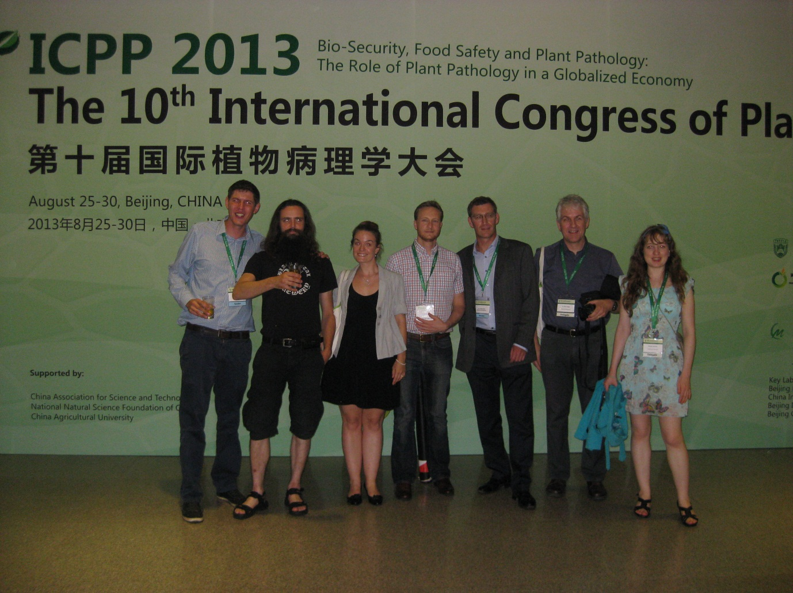

On the ICPP 2013 red carpet following the congress meal together with an epidemic of pathologist from as far afield as Scotland and Rothamsted.