GCRI Travel report – Stephanie Mahon: Sustainable new landscapes in urban China
Background
Hong Kong is a high-density city of more than seven million people. Because of its coastal and mountainous terrain, the population is squeezed into only 30% of the available land mass (40% of Hong Kong is parks and nature reserves and 25% is undeveloped) and lacks free space that could be used for farming – only 2% of food here is grown locally.
Hong Kong therefore depends on imports from mainland China to feed the population, but in recent years there have been a number of food scandals including fake eggs and melamine in baby milk which have put people on high alert and made many consider where they source their food. The Hong Kong Organic Resource Center has stated that after these scares, one third of the city population started to purchase organic food at least once a week, and the local output of organic vegetables has increased by two-thirds in five years.
However, the reality is that organic food is expensive and the quantities required to feed the city cannot at present be sourced locally. Also Cantonese people believe cold food such as easy and quick to grow salad leaves are bad for your chi, and many Hong Kong natives believe working with soil is dirty and beneath them. All of these things have culminated in the rise of many new education-orientated growing projects, and community-led initiatives to promote responsible food production and urban farming as a relational platform to help people connect with their food sources and each other.
In a broader context in wider China, a new programme of large-scale, rapid-build city planning has led to environmental disasters; for example landslides and poisoned rivers in the ‘factory of China’, the city of Shenzhou. The population there grew from 30,000 to 15 million in 20 years and its development into an urban entity was marred with issues, demonstrative of what is happening all over China.
In 1995, there was urbanisation of 10% of the country; in 2015, this was 50%. Many new cities are built on a grid system and according to internationally respected Chinese landscape architect Xiaomei Ma, created just for the sake of growth (examples include Jiang-Jin and Chongqing). He believes planners are not capable of creating new landscapes; the Chinese government “thinks like a business, so these places fail, but they make money from the surrounding area”.
There are also serious issues with pollution and a lack of sustainability, green architecture, ecological thinking and environmental management in these new landscapes. There are, however, several organisations and individuals working to buck this trend.
Summary
I visited eight sustainability-led projects on my trip that demonstrated different motivations and goals. They could be divided into several categories: owner/occupier-led educational and community projects; commercial projects; corporate incentive projects; and self-sufficiency projects. They included rooftop farms on two universities, a school with rooftop garden and closed food-waste recycling system; a commercial rooftop farm leasing space to growers; a corporate social responsibility project which boosted the profile of the company as a leader in sustainability; a family smallholding; an indoor hydroponic farm attached to a restaurant; and an old polluted quarry that has been reworked ecologically to become a tourist attraction.
Key findings
- The need for sustainable local food has not led to the creation of new productive commercial urban farms but instead many projects promoting awareness of the issue of food sourcing. This is the primary motivation in nearly all of these projects
- The most successful projects are not reliant on volunteer engagement but have paid staff or co-ordinators
- There are commercial niches within this sector which have created interesting horticultural business models. These included:
- growing-medium and fertiliser creation/sourcing via food waste recycling;
- linking with corporate entities who wish to use green partners for sustainability kudos or beneficial outcomes such as offsetting emissions;
- businesses which service those who wish to have rooftop farms or wish to individually grow their own food in urban settings in a full service environment;
- redesigning of a ‘bad’ landscape into a ecological visitor attraction.
- Specialist equipment such as UV-resistant, custom-made rooftop growing boxes could be useful for UK projects
- There are crops grown and eaten in China that could be grown more commercially in the UK

Visit 1 – Hong Kong University rooftop garden
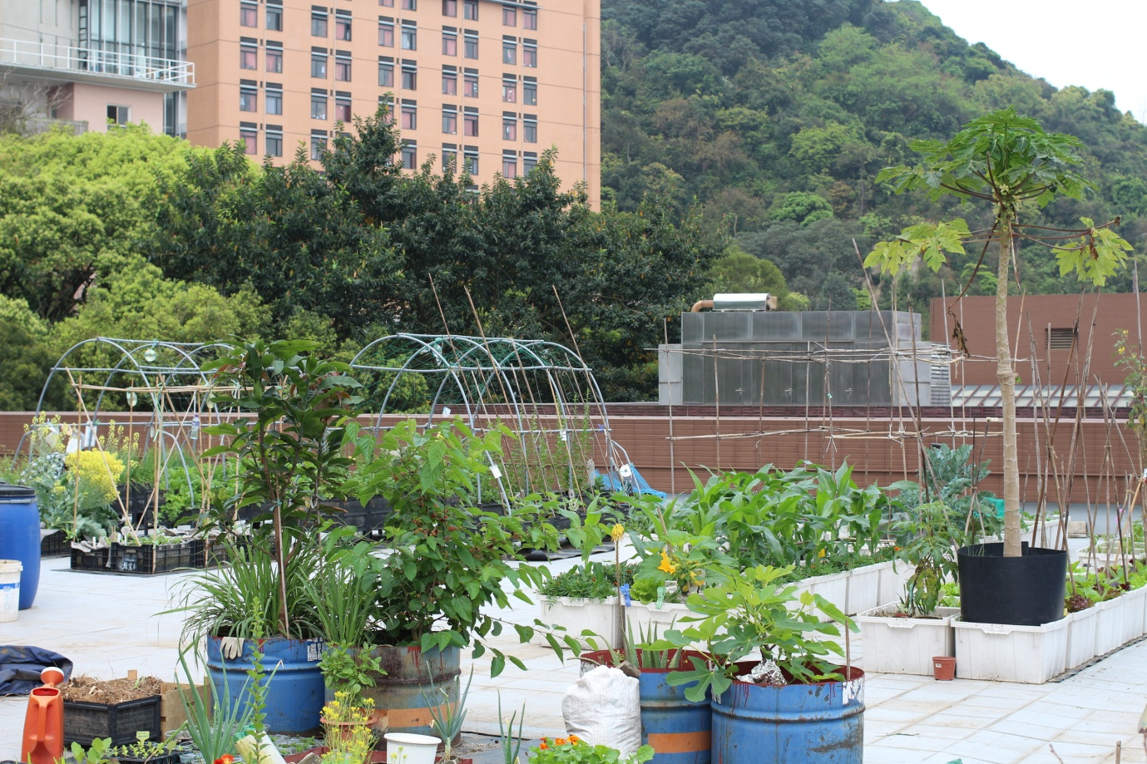
The rooftop garden at HKU is comprised of many growing boxes and miscellaneous containers
The rooftop farm of HKU was started in 2013. It began as a teaching exercise for landscape students. Mathew Pryor of the landscape faculty worked with the final year undergraduate students and the HKU Estates Office to work out the scope of the concept, its construction and ongoing management.
The chosen site was on top of the Runme Shawe Building, a 1980s five-storey building. It was felt it was a good option in that it had a large wraparound roof deck which had proper drainage already built in and a structure that could stand the load of soil and equipment for the garden. On the down side, access to the roof was via heavily trafficked corridors via stairs; and there was an occupied residential unit at one end of the plot.
The flat roof deck wraps around the utilities station for the building (water tank, air-con system etc) so it is open on three sides. It was decided that planter boxes filled with 200mm of soil could be placed across 50% of the area. In total about 500m2 of the roof deck could be used for the garden.
The farm is open to faculty and students who volunteer to help manage and run the project. Presently there are 20 members involved, with two to three people being scheduled to work on the roof each day. There have been some difficulties in maintaining volunteer numbers throughout the year, because students go home for holidays or leave the university, or are too busy studying for exams to help. As such, the maintenance of the space was referred to the General Education Unit who employ a staff member part time to essentially manage the farm and co-ordinate volunteers.
Aside from the usual rooftop growing issues of wind and exposure, another issue faced by the project is typhoons, which turn bamboo poles into projectiles and leach soil from containers. Also the climate becomes so hot in summer that it is difficult to grow anything.
The participants grow in winter, spring and autumn, reliably producing two to three sets of crops a year. As well as the growing boxes, the roof also contains a rainwater harvesting system, a compost pile, a bokashi composting system and a wormery. The composting element of the project is becoming more important as there is a dearth of topsoil available in Hong Kong and so much of the growing medium used on these sorts of projects is a mixture of mineral soils and organic matter such as chicken manure, animal waste and lime – though Mathew Pryor believes that even these products when sourced from mainland China are not trustworthy and may contain chemicals, pesticides etc.
Though the main purpose of this project is not to produce high yields of crops for sale, the farm does in fact give produce to the university’s onsite restaurant.
It was obvious than many participants are foreign students and there is not as much interest from young local Hong Kongers to get involved. As a result much of the produce grown and approach of the project was ‘Western’. The horticultural knowledge level of those I met was basic.
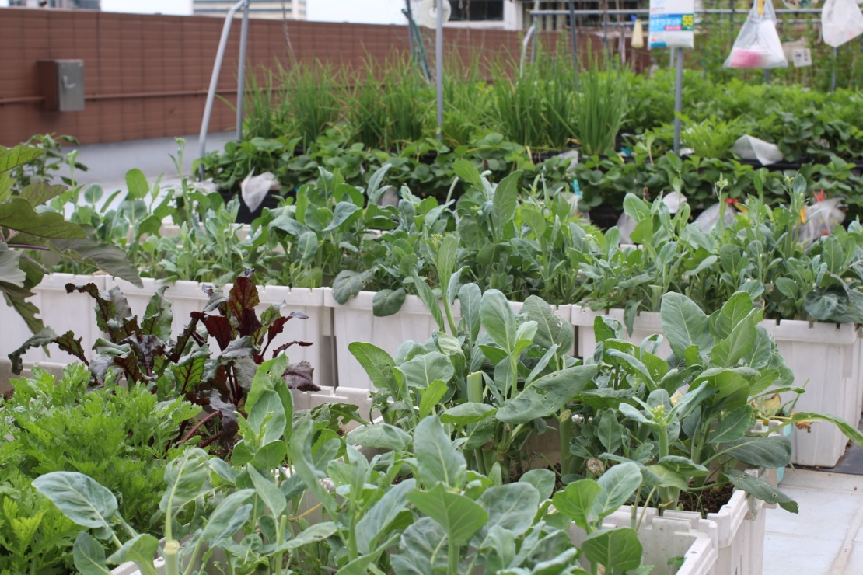
Crops include brassicas, garland chrysanthemum and wheatgrass
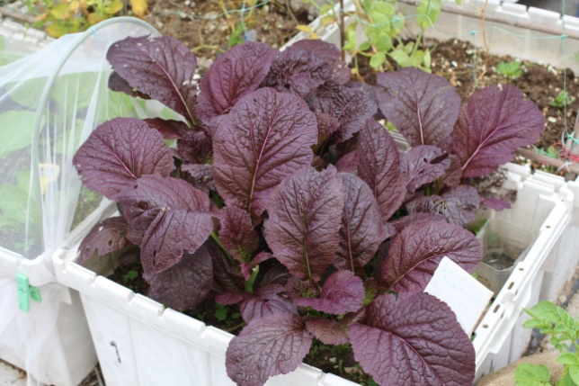
Giant red mustard
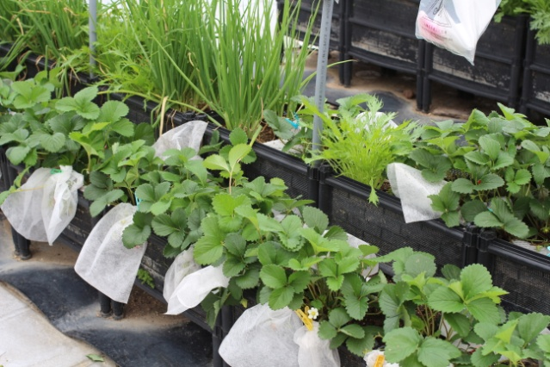
Commonly in China, each fruiting body is protected from birds with fabric baggies or small nets

Visit 2 – ISF Academy composting system
According to charity Feeding HK, more than 3,200 tonnes of food waste is produced in Hong Kong each day. In urban climates such as Hong Kong, emissions from decomposing food have a serious negative impact on air quality. Also, the remaining capacities of Hong Kong’s three landfills will be exhausted in 2018.
As a result, there is a fresh push to look at ways to reduce this waste. At ISF Academy, an independent primary and secondary school, this has led to the installation of a food waste recycling system. Food waste from lunch preparation and uneaten scraps from plates are composted to make a material that will become a part of the growing medium for the school’s rooftop growing plots.
The process is demonstrated in the images below.
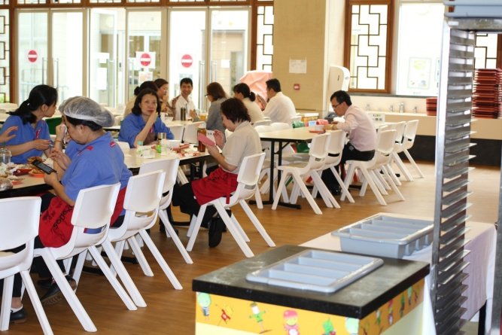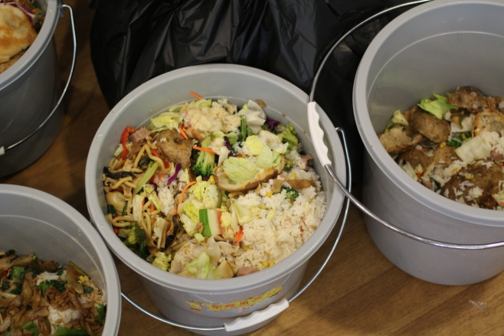
Food preparation and post-meal scraps from the school canteen are collected
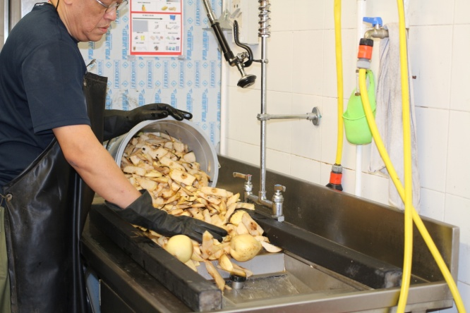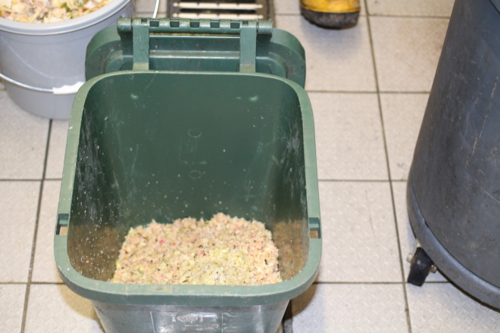
They are put through a special pulverising system in the kitchen
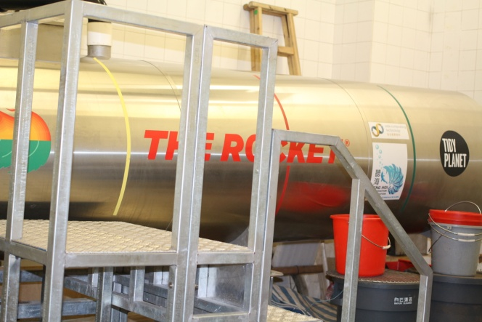 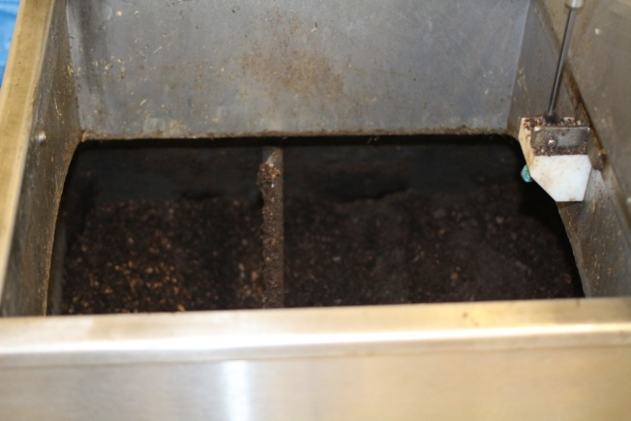The scraps are put into the Rocket Digester
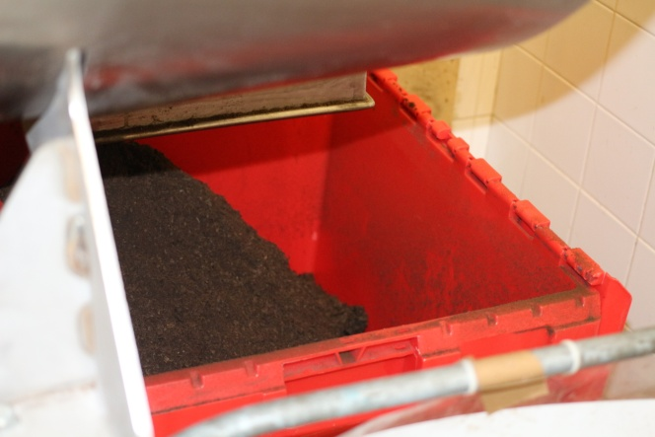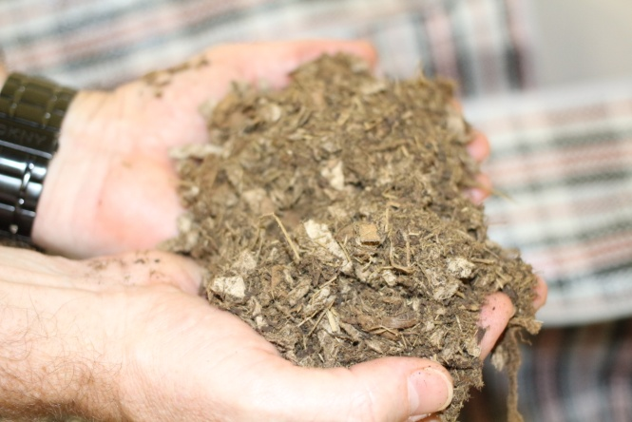
The result has been mixed with wood ‘fluff’ and well-rotted horse manure is sometimes added
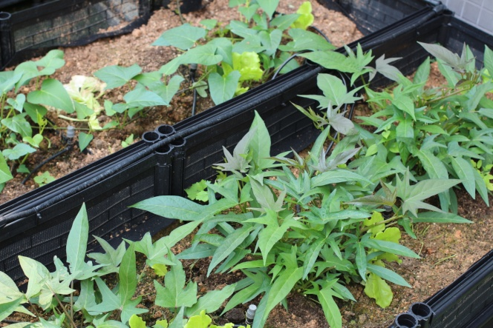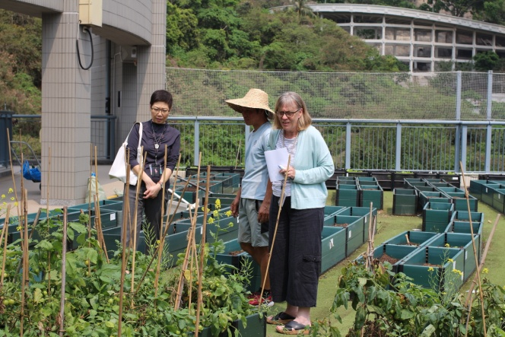
This medium is used in the growing boxes on the school’s rooftop kitchen garden
The system was set up by George Woodman of Teng Hoi, a non-profit conservation organisation, and Diana Lynne Ibarra, Shuyuan Science and Sustainability Programs Manager at The ISF Academy. A similar system was set up by George at a different school and after visiting, Diana decided to make it the first whole-school sustainability project she implemented.
There were some problems at first getting the ‘recipe’ right as the Asian diet at the school was different from the ‘Western’ diet at the other project – less leaves and more meat and rice, which is difficult for the composter to metabolise. The Rocket Digester vendor Tidy Planet created a biofilter for the school which eliminated much of the odour problem. Now the process is used to show students that “A circular economy is normal and you can do it”.
It began with the after-school environmental group the Green Gardeners, who collected data about food waste at the school and found that for the one meal of lunch a day, there was 90g of food waste per day per child. Over 190 academic days, that’s 27 metric tonnes of food waste.
The system, which is anaerobic, was installed at the end of November 2014. The school leases everything from Teng Hoi, and pays them a monthly fee to maintain the system - it is a process that needs to be managed. The school is now composting about 60% of the cafeteria’s waste.
The resulting material is fertiliser grade. It is being used to run gardening classes and after school activities, and Diana believes that the rooftop gardens will see 500 kids organic farming over an academic year. The composter and resulting material are also to be used by students on biology projects in the future. The material may end up being a commercial product the school can sell.
It has also helped the school make connections with corporate and community organisations. Jonathan Wong, a solid waste expert from Baptist University Hong Kong, came to see the school’s system and recommended they go for a HSBC grant, so Diana applied and the organisation gave them enough money to create 20m2 more space to grow. Also, The Jockey Club (a private members’ club and philanthropic association) has become involved. They stable about 1250 horses in Hong Kong and usually import bedding from all over the world, but are now looking into using the school’s composter to help create a cardboard-based, dust-free product to use instead of wood shavings or straw. They have also talked about donating well-rotted horse manure to supplement the material from the composter to make it a fully-rounded nutritious growing medium.
The airline Cathay Pacific has shown an interest in using the school’s composting initiative to offset carbon omissions for the company. There is a technical requirement to show they are offsetting emissions, and so the school needs to monitor which gases are present and how much of them, which requires expensive diagnostic equipment. Preliminary trials using the Gasmet Portable Analyser from Finland have been promising.
As a result of the system, the school is also presently going through an accreditation process with the international Council of Schools to be credited as one of the top 5 around the world for sustainability.
Diana believes the composting system has been a great way to engage with the stakeholders of the school, and has given the academy a “conversation venue” with a lot of other organisations. It has allowed for student-led science research, and showed that ISF can be a community leader. The composting system is now part of the tour of the school for prospective students and investors.
It has obviously been of great benefit to the school on several levels, but George Woodman does not believe it is a viable option for organisations in general as it is not running at full capacity and so is not efficient; and it is expensive to install and run on such a small scale. The ideal and most efficient and cost-effective system, he says, is one where food waste is transported or collected from various large institutions such as schools, universities, hospitals, office cafeterias and restaurant/cafe chains, and brought to a single location for recycling.
There are several companies doing this at present in London and other UK cities, with the resulting material being sold to agricultural companies, but as yet it has not been possible to implement in Hong Kong, due to bureaucracy and the worry of “losing face” over the fact that many institutions’ already-installed composting systems are not working. Culturally in China it is common to stay quiet about issues such as this, rather than raising them to solve the problem. Failure and loss of face are not acceptable in society or the workplace.
The encouraging finding from this project is the efforts being made to create usable growing material for horticultural purposes from food waste on a pseudo-commercial scale.

Visit 3 – City University Hong Kong
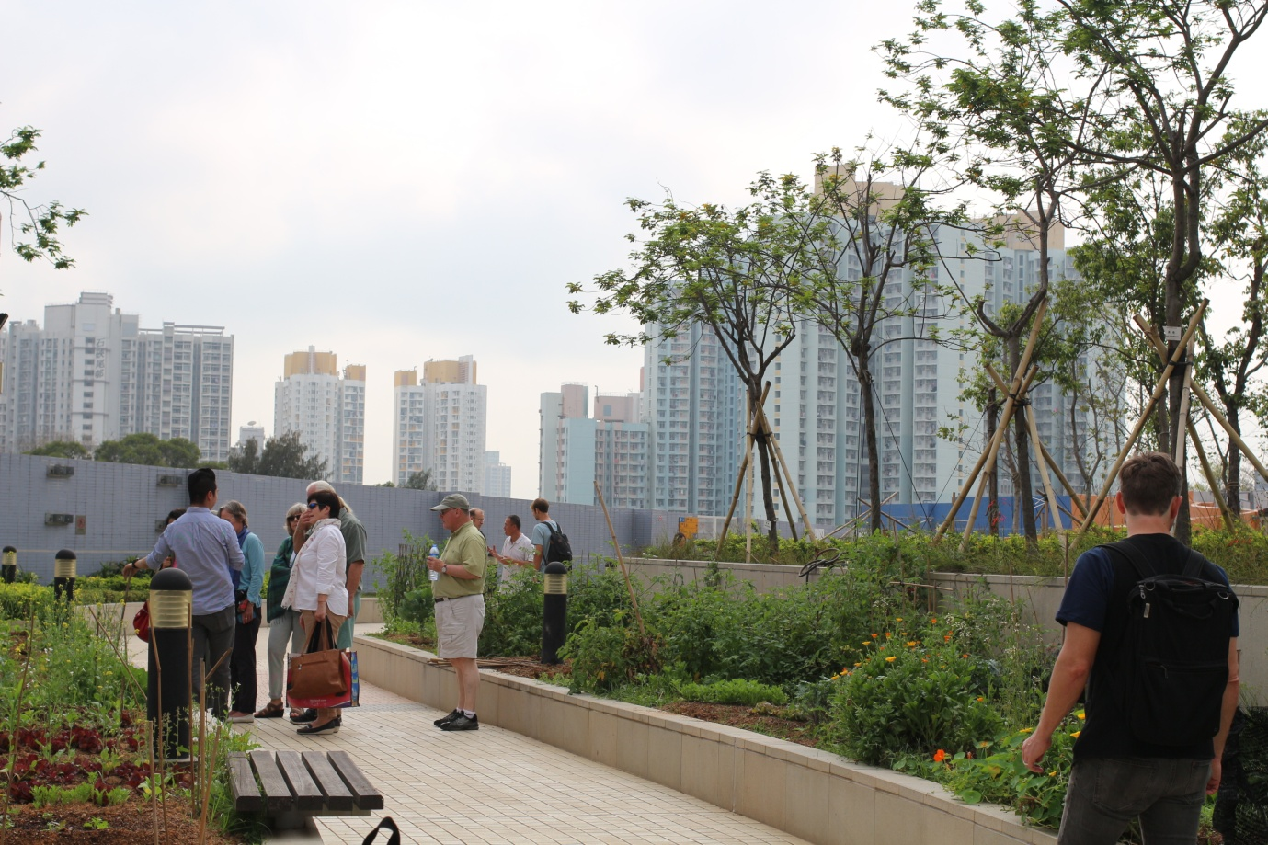
The rooftop garden at City University
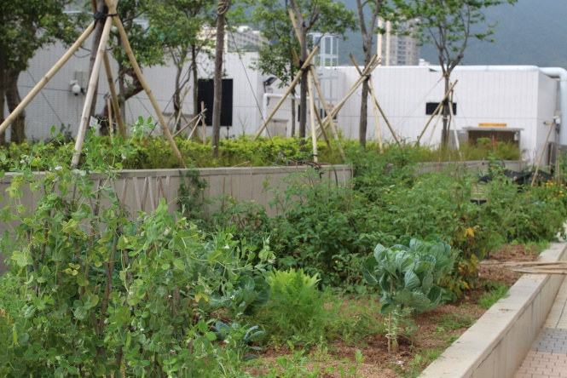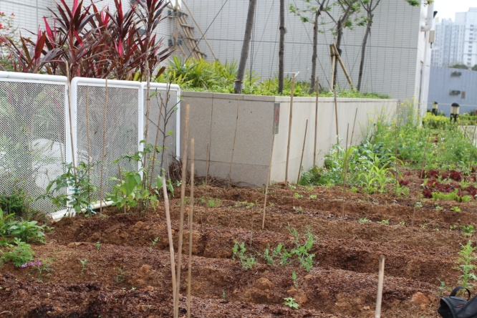
This project utilises existing raised beds to grow crops
I was brought to City University’s GROW rooftop farm by Chris Mattison, a former faculty member of the university who had set up the project but since moved to HKU. He offered plenty of information about the start-up of the project and its development until he left (see below); but unfortunately at the time of my visit there was not anyone in charge available or willing to update me on the present facts and figures of the venture or explain future plans and initiatives.
Hong Kong’s University Grant Council imposed a mandate for universities throughout Hong Kong to address sustainability on campus. The Provost’s Office at CityU decided to start the Campus Sustainability Fund, which led to the creation of the rooftop farm.
The farm is situated on top of a high-rise building, AC2, on the university’s campus in Kowloon Tong. Unlike the empty flat roof terrace at HKU, here there was a built system of raised beds in place, used as an ornamental garden of trees, shrubs and tropical plants. The site also includes windbreak structures and access and hanging points for window cleaning equipment. Some of the raised ornamental beds have been given over to growing crops. They comprise five beds of 2m x 2m. There are also trees planted at a higher level with a greater depth of soil.
During Chris’s tenure as director of GROW, the participants grew Chinese vegetables including bok choy, tatsoi, choy sum, fung tsing tsai and water spinach as well as non-native fruit such as papaya. During my visit I spoke with one post-doc student Dr Benjamin Tarver who was using his plot on the farm to grow salads and more ‘Western’ crops.
The original idea of the farm was to engage the university’s students and the local community. There are a few students who remain engaged with the farm but in general ongoing involvement has been a challenge. To ensure continuous involvement a core group of students are paid to maintain the farm; another group use the space to create their student service projects; and another group use it as part of their coursework. There was hope the farm would enable the university to develop community involvement with local schools and senior centres, but this has not yet materialised.
In all, there were no major findings from this particular visit as after Chris’s departure the project seems to have stalled somewhat in pursuing its goals. The HKU project was overall a better example of an institution-run sustainable growing project with education at its heart.

Visit 4 – City Farm
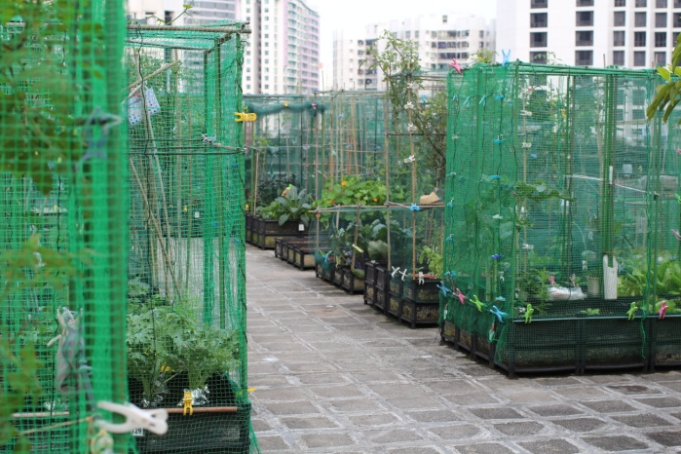
City Farm has three rooftop plots in Hong Kong
City Farm is a commercial project which is located on three different rooftops in Hong Kong. I visited one of the sites near Quarry Bay on Hong Kong Island to speak to founder Osbert Lam, a native Hong Konger who started the business five years ago.
It is commercial in that it recoups costs from renting growing boxes to clients; it does not sell crops. The business also sells seedlings and homemade soap, and runs how to grow and how to garden courses at the farm.
Osbert was a hobby farmer, and found there was a rooftop space above his office (he works as a sound engineer) so started growing vegetables. Other people got involved and then he started running courses and decided to share the growing space. He now employs part and full time staff at three venues.
The rooftop in Quarry Bay is above an office building. It comprises 1000m2 of flat roof with a central hut containing facilities and utilities. This one rooftop services 200 clients and about 60 students who are taking courses over three levels of knowledge. They come every other week for 1.5 hours on weekends to follow growing through the year.
The farm consists of 500 planter box units which measure about 60cm x 19cm and can hold a 50cm depth of soil, which Osbert says is good enough to grow most kinds of vegetables. The special boxes come from Taiwan, where urban farming is advanced. They are made of treated plastic which can withstand UV rays, and heat, making them stable all year round. They are lightweight and last about five years, and don’t break down as fast as normal plastic vessels would.
The sides are perforated with lots of tiny holes, which give good air flow and drainage. There are three modules sizes used to achieve different heights for ease of growing, or offer a greater depth of soil for some vegetables. Osbert believes that with the right knowledge, you can produce about 30-50lbs of produce from every box in a year. In summer though there are less options because of the extreme heat, they grow about 30-40 different varieties of vegetable; in winter, they grow at least 60-70 varieties.
City Farm does its own composting to create soil material. The right soil is almost impossible to source in Hong Kong according to Osbert. Even available commercial compost is not suitable as heavy rainfall from typhoons can wash it away. The right growing medium needs to have good drainage but also store nutrients. The farm staff mix their own growing medium to make it work for local crops using imported peat moss, vermiculite, compost and coir.
Clients take up to 10 growing boxes each and pay circa £30 per month per m2 to rent them. They get boxes, soil, seeds, bird nets, lockers and some help growing, watering etc from staff. Most clients are middle class, educated Hong Kong women with families.
It is commercial, self-sustaining business, but Osbert is presently looking into making a social enterprise. The business model works particularly well in Hong Kong because you can grow almost year round, with up to three sets of crops a year. Although this is not the case in the UK, there are still things to be learned from Osbert’s concept.
Many rooftop farms/allotment schemes in the UK are run as council-run/community ventures and are meant as educational, outreach or engagement projects, but it is possible that there is room for a more commercial service-industry approach in cities where urbanites want to grow for themselves without being part of a committee/group and have the hassle taken out of it by having the growing utensils, soil, seed etc organised for them and knowledge on hand when needed.
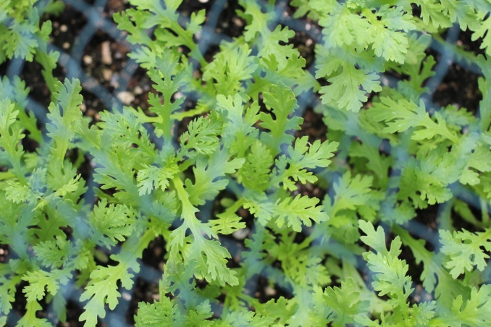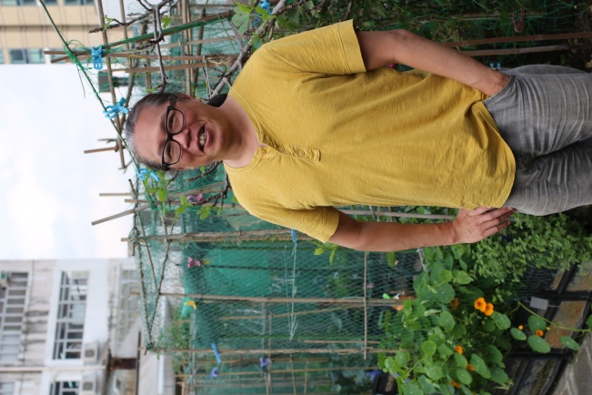
Garland chrysanthemums (Chong Ho/Tong Hao) City Farm founder Osbert Lam
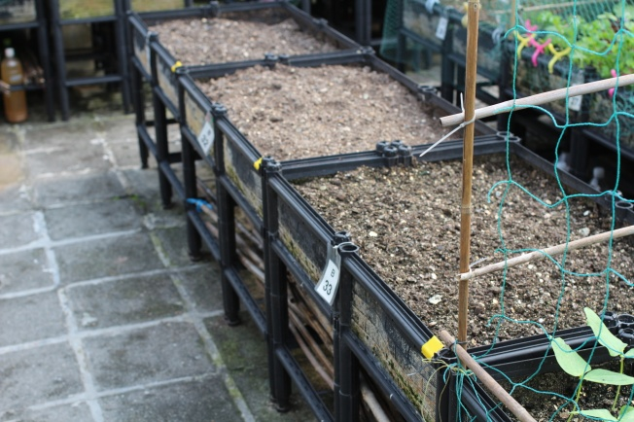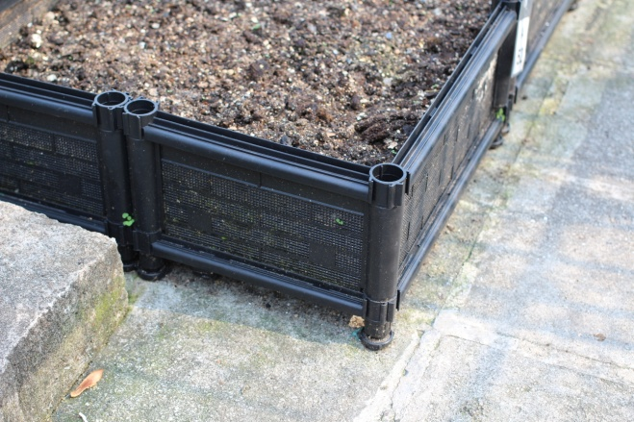
These growing boxes are made in Taiwan especially for rooftop growing.

Visit 5 – Bank of America Tower rooftop garden
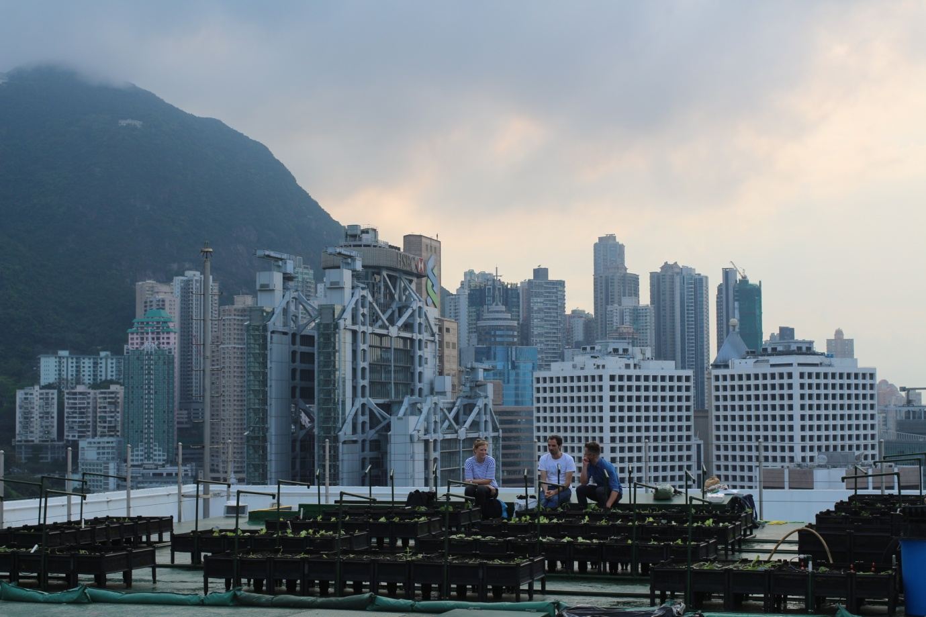
The Bank of America rooftop in the Central Business District
The Bank of America Tower is a ‘skyscraper’ in the CBD on Hong Kong Island, managed by Jones Lang LaSalle. The farm on the roof was started in 2013 as a corporate social responsibility initiative. The company wanted to promote healthy living and sustainability and take a leadership role in the community - this would be the first rooftop farm in the district and JLL wanted to set an example with a pilot project.
The rooftop was assessed for loading and a barrier constructed around the outside for safety. Then JLL contacted Time to Grow, a green enterprise dedicated to creating green spaces such as rooftop farms in the city. Time to Grow brought in the soil, boxes etc and set up the farm, and used their connections with farmers in the New Territories to source seedlings. They planted up the farm and offered training to JLL staff in growing.
The ongoing running of the farm was supposed to be managed between the New Territories farmers and the JLL staff, with some events organised by JLL inviting other staff, visitors and people to plant up each season. However Time to Grow remained involved to co-ordinate as access to the roof is limited and conditional on all the tenants in the building, especially those on the top floor, not being disturbed. Only 14 people at a time can go up there at agreed times and everyone must sign in.
Since the farm was set up, Time to Grow has closed and its founders have split into other groups. One of these is Rooftop Republic, a company that provides growing materials, equipment, services and expertise to projects. Rooftop Republic now manages the Bank of America rooftop farm. On my visit I met Pol Fabrega of Rooftop Republic who was in the process of setting up the summer crops on the farm with one staff member and one intern. They were growing salad leaves, as they do not require much care other than watering, which is done on an automatic irrigation system.
In the first year of the project, the produce went to JLL employees, but since then the harvests have been donated to Feeding HK, a charity which runs food banks in the city, and the Society for Community Organisation (SoCo). JLL holds an event every time there is a harvest.
The rooftop farm garnered a lot of media attention for JLL and the BOA Tower. Tenants in the tower have asked about volunteering possibilities for their staff, and other buildings in the district have asked for information about the project. JLL likes to invite clients to visit the farm and plant seedlings, and has also invited disadvantaged children from a local school to harvest the crops and learn about farming.
The horticultural aspects of the project were not particularly advanced and it does appear to be a vehicle for the company to satisfy CSR and sustainability criteria and create positive publicity with clients, staff, other businesses and the media.
The interesting part was seeing how corporate entities benefit from projects such as these and how they seek ‘expert’ companies to create and manage such projects. Rooftop Republic is another business model – beginning as a social enterprise, it is now a commercial company servicing blue-chip companies and private clients in setting up and managing their rooftop farms (the BOA farm cost JLL circa US$20,000 to set up, before maintenance fees). Rooftop Republic assesses what is needed and possible for each project, sources all equipment and growing material, offers training and education programmes for participants, and co-ordinates ongoing harvesting and planting via suppliers.

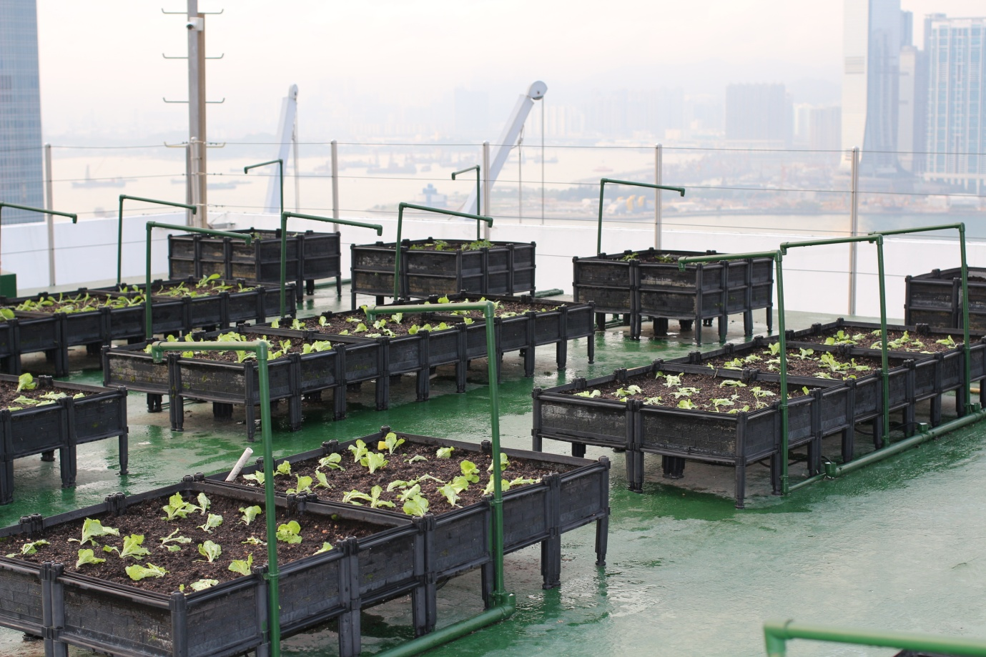
The bank’s rooftop farm has an inbuilt irrigation system
Visit 6 – family smallholding, Cheung Chau
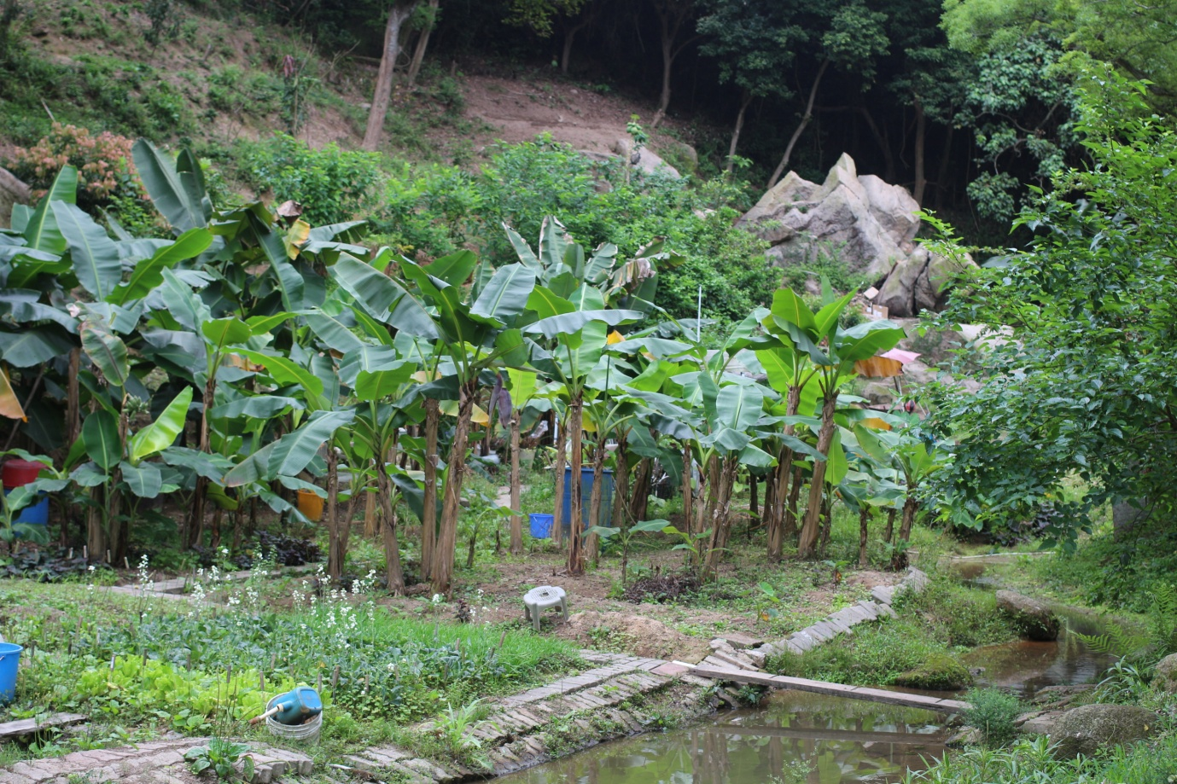
Banana grove on the family smallholding
During my trip I was able to arrange a visit to a traditional family smallholding on the island of Cheung Chau, Hong Kong, a 30-minute ferry ride from Hong Kong island. The family don’t speak English and so my guide was Wanda Huang, a foraging expert who works for a non-profit project called Growing Smart HK, which raises awareness of permaculture.
The visit was informative in terms of the smallholding being a sustainable landscape that allowed this family to be self-sufficient in vegetables, fruit and eggs from chickens; and in terms of discovering what native Hong Kong Chinese people grow to eat.
Wanda pointed out many crops used in Asian cuisine; some are not commercially grown here but harvested only by home growers such as this family. Other plants they grew are familiar to us and are usually imported into the UK – some could grow here but are not widely appreciated or grown commercially.
The plot was laid out in small sections with reclaimed bits of wood, brick and stone, plastic piping etc. A small stream ran through the area, and was used to grow watercress. Wild flowers such as lantana, considered a bedding plant in the UK, grew everywhere. Surrounded by lush jungle, the smallholding has to be constantly managed to keep it clear of invading vegetation.
The family enjoy a high level of productivity in vegetable and fruit crops from the land, which covers about half an acre (though parts of this are taken up by huge boulders and a through path put in by the local authority). Produce from the smallholding included Malabar spinach, celtuce, mustard greens, spaghetti squash, hairy melon, Chinese cucumber, Garland chrysanthemum (crown daisy), lychees, longan, longsat, ginger, tamarind and galangal, papaya, apricots, watercress, taro and bananas.
Notable crops that are not grown commercially included the fruit of the whampee tree, which is like a small orange and is used medicinally and as a cleanser and astringent. The leaves can be smoked, and the peel can be pickled or salted. It needs a subtropical climate. True rose apples, not to be confused with jambu or Malay apples, produce a perfumed fruit that smells like honey and roses. There isn’t much flesh to each fruit so it has never been worth growing commercially.
The family also grew a whole complement of leaf vegetables, some of which we are familiar with in the UK. They included:
- Bok choi, Brassica rapa subsp. chinensis, both shortleg and Shanghaiese types (which has green stalks and leaves)
- Choy sum, Brassica chinensis var. parachinensis, grown for the heart and not the leaves (for that they grow baby choy sum). Has a buttery, nutty flavour.
- Tatsoi, Brassica narinosa, which grows flat, like a rosette, and has spoon-shaped leaves.
- Kai choi, Brassica juncea, a variety of mustard greens. Used worldwide for canola oil and scattered throughout the northern hemisphere as a ‘weed’/casual alien species. Also giant red mustard, which is eaten in UK as leaves in pre-packed salad bags from supermarkets. The family don’t eat mustard leaves raw but pickle the stalks and use smaller plants in stir fries. Most mustards are all season crops in the UK.
- Amaranth (Chinese summer spinach) – the species A. dubius, for the leaves. Grown elsewhere, other species, for the seeds. The leaves can be used like spinach; the seeds used like a grain.
Wanda, who is of Asian-American background, has a good understanding of international agriculture and horticulture and believes these leaf vegetables would/do grow well in the UK. This is borne out by the fact that speciality growers such as Cherry Farms/Rokewood in Wisbech are already doing so, profiting from an increasing interest in Asian food by growing many Oriental vegetables under cover and selling to restaurants and supermarkets.
The most interesting crops in my opinion were amaranth and the crown daisy, in terms of possible value to the UK horticulture industry.
Suttons Seeds has two types of amaranth in its James Wong seed collection, but they are seen as fun/fringe gardening for novelty rather than mainstream growing options. Amaranth is the sort of plant, however, that could attain the marketing tag ‘superfood’ and garner the attention of the sorts of consumers and gardeners who buy quinoa, chia seeds, goji berries etc. But unlike many of those products, amaranth can be grown here. The leaves are purported to contain more iron than spinach and high levels of vitamins C and D. The seeds as food, sold as a grain substitute in wholefood shops, are usually imported. They supposedly have more nutritional value than quinoa. Both can be grown as an annual from a spring sowing in the UK.
Garland chrysanthemums are grown for the leaves but are known in the UK as an ornamental daisy. These greens reportedly aid weight loss and help protect against lung cancer. These alleged benefits may or may not have scientific backing. However, there is a belief in those who eat them that these things are true.
I plan to trial these and other Chinese leafy greens on my own allotment next year.
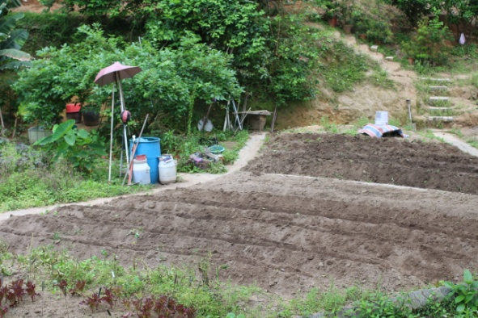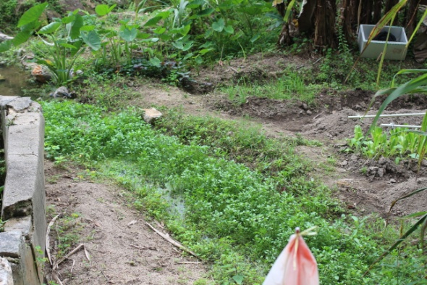
A section ready for sowing Watercress growing in a stream
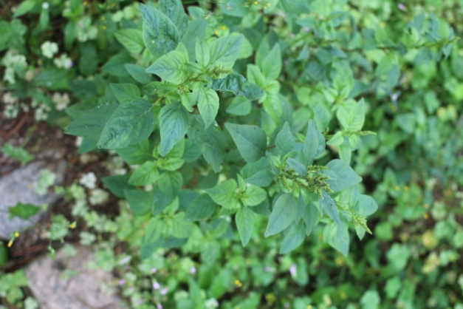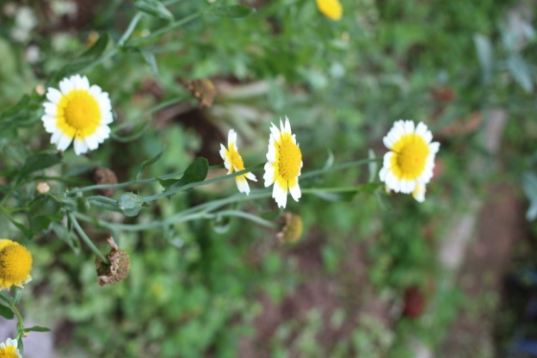
Chinese spinach/Amaranth Crown daisies
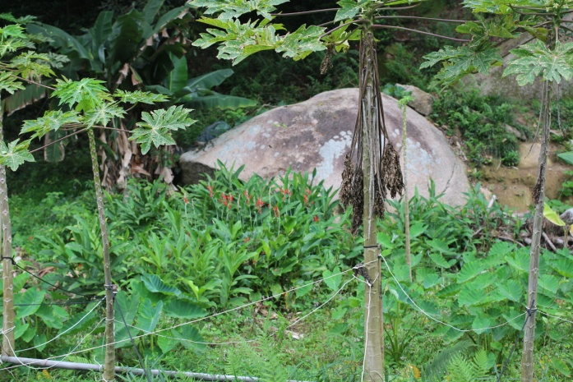
Taro and ginger growing underneath papayas

Visit 7 – Fresh N Green hydroponics
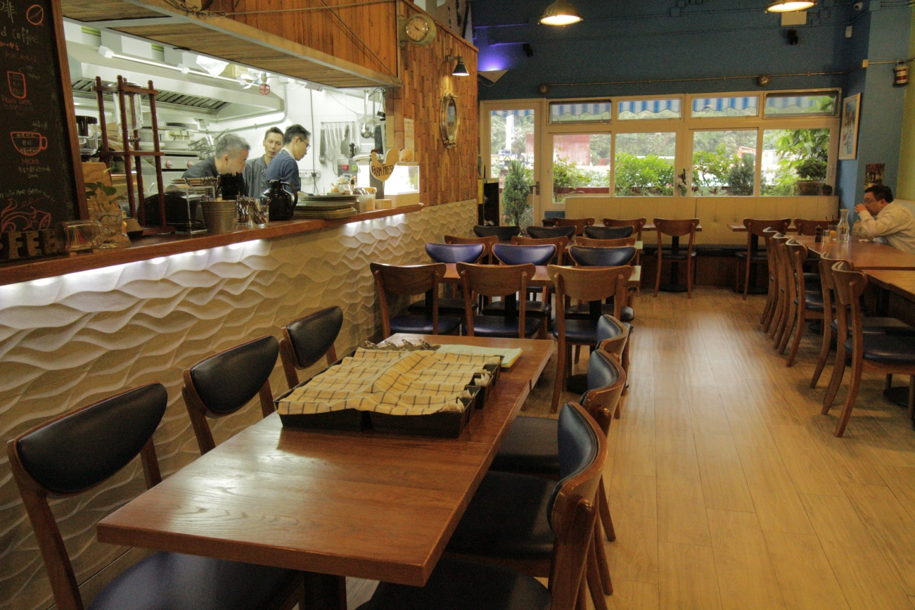 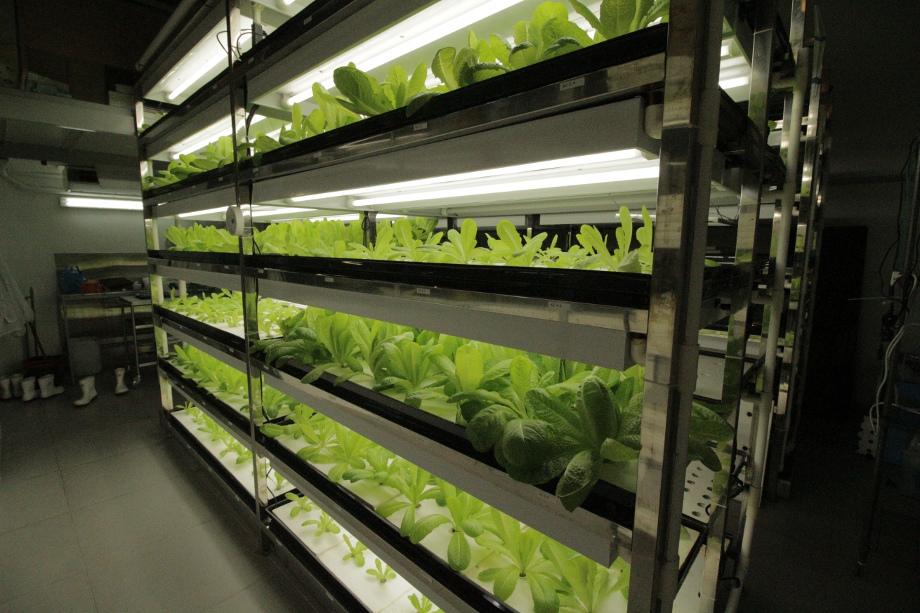
The restaurant The hydroponic growing room
Fresh & Green Italian restaurant is situated on the second floor of the Worldwide Industrial Centre in Fo Tan in the New Territories (the suburbs and hinterland of Hong Kong, reaching from the city to mainland China). It is run by Ken Yuen.
His intention is to educate people about where their food comes from and to encourage discussion about carbon neutral crops. Beside the restaurant, there is a specially built chamber which is temperature controlled. Here Ken grows predominantly salad leaves through a hydroponic system.
He grows from seed, placing the resulting seedling into a piece of cut sponge, which then gets inserted into a tray that sits above a reservoir of nutrient-rich water.
The water is run through banks of these trays which sit in shelving units with growing lights. The water comes in off the mains is filtered and passes through chambers of nutrients before running past the roots of the plants.
Ken uses the resulting produce in the restaurant and has hopes of growing strawberries, herbs and other fruit and vegetables in the future, but is wary of expanding too fast as he feels there is not yet a demand.
The rest of the produce for the menu is sourced from local organic farms. The menu is ‘Italian’ but appears to be a fusion Asian-European-American with dishes such as burgers and pasta. The emphasis is on freshly harvested vegetables and home roasted coffee.
Ken also offers mini hydroponics growing kits for sale and occasionally hosts classes in hydroponics. He mentioned he knows people who practice the closed system of aquaponics with fish, but to sell those sorts of crops in his restaurant he would have to have constant scientific monitoring to ensure no waste product contaminated the food, and this is too expensive at present.

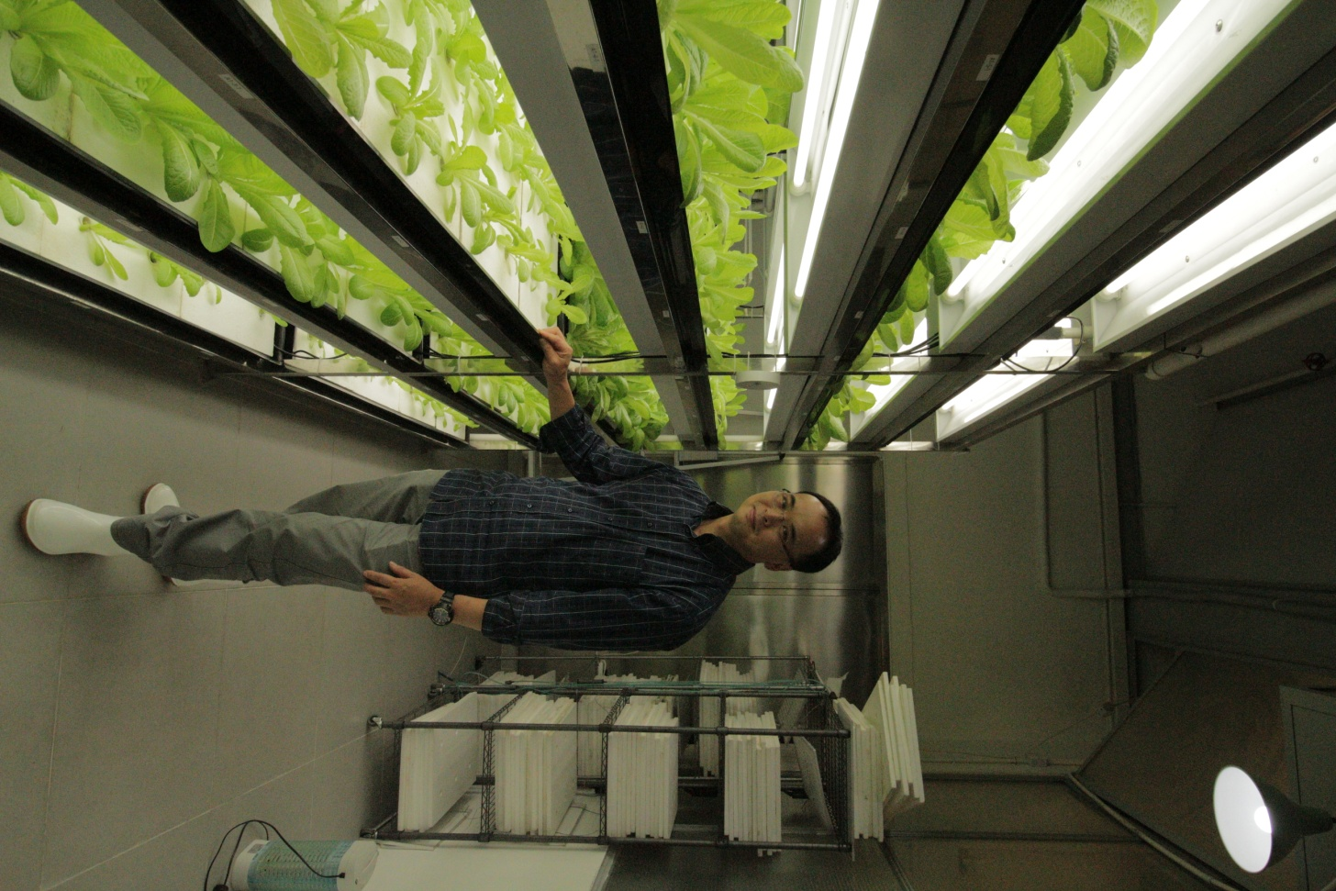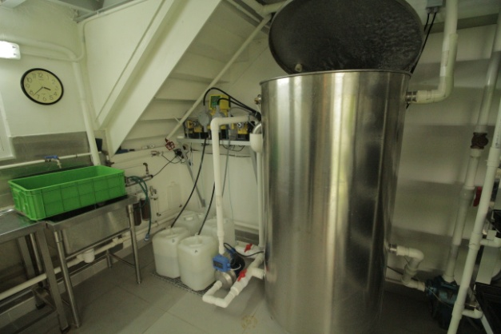
Ken Yuen This system filters and adds nutrient to water
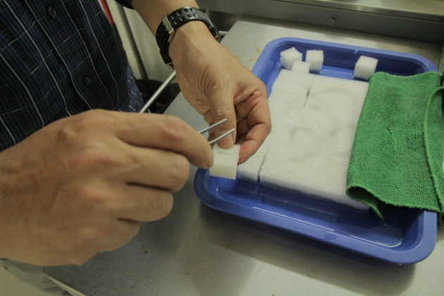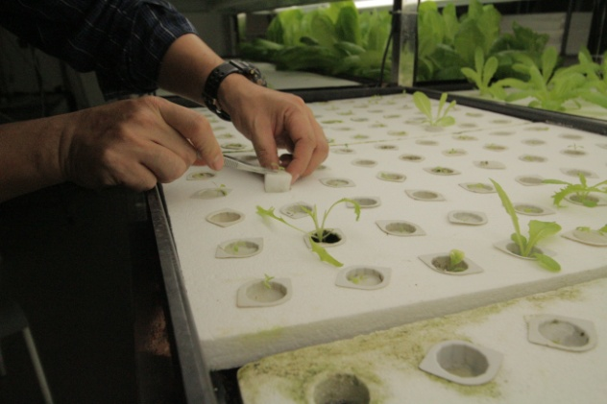
Seeds are sown individually into sponge squares, before being placed in small pods

Visit 8 – Quarry Garden, Shanghai Chen Shan Botanic Garden, Shanghai
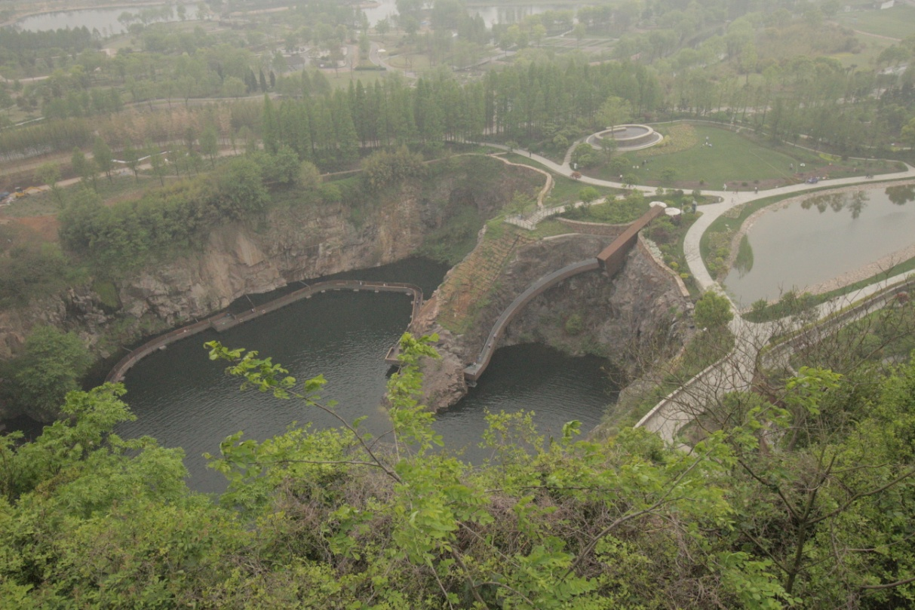
The Quarry Garden which now forms part of the Chen Shan Botanic Garden, Shanghai

Though China has been developing rapidly in the past 50 years, and many new cities have sprung up in a matter of months, there is a smaller but growing landscaping and planning movement focused on the sustainability and ecological factors of places.
Shanghai is the most populous city in the world and the garden though still in Shanghai is actually almost 2 hours’ drive from the city centre. My guide Nancy explained on the journey how the city sits at the convergence of several rivers, which have had massive pollution problems even the past decade. The air is also heavily polluted with a white haze constantly sitting over the lowland region; even the hot sun fails to burn it off (the photograph above was taken on a ‘sunny’ spring day which hit 34 degrees).
The 10-acre rock quarry was once a mountain with a famous tourist resort based around it, but it was turned into two quarries to fuel development. Once mined, the quarry had been abandoned. According to ASLA, this is an issue because “Depleted of their mineral resources, many of these quarries fill with water and form dangerous lakes, while others become landfills that subject nearby residents to pollution.”
This presented an opportunity to change the quarry into an eco-friendly open public space that would restore biodiversity, capture water and use waste. The landscape practice THUPDI worked with the Department of Landscape Architecture, School of Architecture, Tsinghua University; the Research Center of Landscape vs Design Study; and the Beijing Tshinghua Urban Planning & Design Institute to come up with a new design to transform the area.
The design team took six years to reconstruct the landscape. Many of the rock surfaces were left alone but the land was reshaped. Now visitors descend a Corten steel staircase along the edge of a 2.5-acre pool which covers the bottom of the quarry, and continue on decked boardwalks on a route around the pool. Information is provided on the history of the Chinese mining industry and its environmental impact.
The project was opened to the public in 2011, and it now receives 10,000 visitors a day. It is a real success story in how a poisoned site can be environmentally rehabilitated to become a biodiverse place with great design that draws and awes people while educating them about the past and the importance of sustainable landscapes.

ENDS

