**Report on attendance at the International Conference on Brown Marmorated Stink Bug, Tbilisi, Georgia, 2019 (**[**http://conference.nfa.gov.ge/**](http://conference.nfa.gov.ge/)**)**

**Dates of travel:** 9-16 March 2019

**Name of GCRI travel grant recipient:** Dr Glen Powell

**Headlines**

* Brown marmorated stink bug (BMSB) is capable of causing significant economic damage to crops relatively rapidly after colonizing a new geographical area. The pest was first detected in the Caucasus country of Georgia in 2015 and decimated hazelnut production in Western regions in the 2016 season.
* Control of BMSB in Georgia and elsewhere relies on application of broad-spectrum insecticides. The pyrethroid bifenthrin (not approved for use in the UK) is used extensively for BMSB control in Georgia.
* Attract-and-kill approaches (combining aggregation pheromone attractants with insecticide treatment of aggregated bugs in specific areas) are being developed in the USA and show encouraging results.
* Populations of BMSB have not yet been recorded in Australia or New Zealand, despite growing numbers of interceptions of the pest with imported goods. The extensive and proactive steps being taken to stop entry of the pest and respond effectively in the event of an incursion include: offshore treatment of cargo from high-risk countries; deployment of sniffer dogs trained to detect BMSB; widespread use of pheromone-based monitoring traps; approval for release of an exotic natural enemy of BMSB in outbreak areas.

**Background**

The brown marmorated stink bug (BMSB, *Halyomorpha halys*) is an invasive shield bug from Asia that has spread around the world, causing extensive crop damage in North America and Europe. In the UK, top fruit crops are at particular risk of damage, but the insect also feeds on and damages a variety of other glasshouse and field crops including sweetcorn, tomato and pepper. At NIAB EMR, we initiated a small-scale pheromone trapping programme in 2018 to survey for the presence of BMSB (part of AHDB project TF 223). Although the pest has been intercepted with imported goods on several occasions in the UK, we have no evidence for establishment of a breeding population and the 2018 traps caught none of the target invasive species. We will repeat our surveillance activities in 2019 and the meeting in Georgia was a timely opportunity to learn more about this likely imminent threat to UK horticulture.

**Travel findings**

The conference was based in central Tbilisi (The Biltmore Hotel) and provided an opportunity for international scientists, pest control specialists and biosecurity experts to meet and exchange knowledge relevant to the invasive pest and its control. BMSB arrived in Georgia in 2015 and rapidly started to cause damage in hazelnuts, one of the most important crops in the Western regions of the country. Georgian scientists and policy makers shared their experiences throughout the conference. We heard that Georgian agriculture and horticulture is built on a multitude of smallholder farms, with 67% of farms less than 1 ha and only 10% of growers farming an area greater than 5 ha. Most growers have small plots close to their homes, which complicates pest surveillance and response efforts. BMSB had a huge impact on hazelnut and sweetcorn crops within the first year of its detection in the country, with $50 million losses in hazelnut production alone in 2016. The pest has also caused extensive urban nuisance problems as householders living near forests in Western Georgia have to deal with thousands of bugs coming into their homes to overwinter each autumn.

Although the country was unprepared for the arrival of BMSB, and it was not possible to mitigate against initial damage to crops in 2016, international collaborations with IPM experts in the USA and Italy were established quickly. With the benefit of shared experience and advice from international experts, effective monitoring and control measures were put in place, funded by the Georgian Government. By the 2018 season, the extensive monitoring effort (with pheromone traps deployed at 8000 sites across Georgia) enabled the occurrence and spread of the pest to be mapped in detail. This has been accompanied by an extensive media campaign to raise awareness of the pest. Management measures have including the provision of backpack sprayers and staff trained in pesticide application as assistance to smallholder farmers. The most common pesticide used is the pyrethroid bifenthrin, and more than 80,000 ha were treated with this and other broad-spectrum insecticides in 2018. As a result of these combined strategies, Georgian IPM experts are starting to gain some confidence that the year-on-year increase in pest numbers and damage between 2015 and 2017 may have reached a plateau and is possibly starting to decrease. Early indications are that 2018 damage may be less than that recorded in 2017. However, although damage is currently limited to the Western regions of the country, BMSB also has potential to feed on and damage grape vines and there is a great deal of concern that the pest is likely to spread to the most important areas of wine production in the East of the country.

The conference also included several presentations from international experts sharing their experiences of managing the pest and deploying phytosanitary measures used to limit its spread in other regions of the world, including the USA, Russia, New Zealand and Australia. In the USA, where the pest arrived in the mid-1990s, the biggest impact was initially domestic with homeowners plagued by large aggregations of bugs in their houses. However, from 2010 large losses to apple and pear production were seen, alongside an increase in pesticide applications to these crops from 4 to 10 sprays per season. Professor Greg Krawczyk (Pennsylvania State University) described the “attract and kill” system that has been developed and trialled in Pennsylvania orchards. Individual apple trees around the edge of orchards are treated with high doses of pheromone to attract the pests and sprayed at weekly intervals. Results have been encouraging, with reduced fruit damage per tree compared to standard grower treatments. A modification of this approach involves treating nets with pheromones and pesticides instead of trees, enabling effective kill of the target pest without applying insecticide to the crop.

Biosecurity experts from Australia and New Zealand presented summaries of the substantial efforts they are making in their attempts to keep BMSB out of those countries. The insects tend to over-winter in human-built structures (e.g. buildings and vehicles), and are known to hitch a lift in cargo and luggage. Initial surveillance efforts in Australia were focused on passenger luggage at airports, but it quickly became apparent that shipments of imported goods pose much higher risks of introduction. Since 2010, Australia has seen exponential growth in the numbers of BMSB interceptions. The risks are particularly high for shipments of goods such as cars and machinery, with greater numbers of interceptions on ships from Europe and USA than from Asia. High-risk shipments are required to provide certificates showing that the cargo has been treated offshore (heat treatment or insecticide fumigation) before they are permitted to dock.

In New Zealand, BMSB is the highest priority pest and is targeted with substantial detection and response efforts to stop the insect arriving and establishing. Sniffer dogs are trained to detect the odour of the pest, conditioned using volatiles from imported dead insects. A BMSB Council has been set up with various grower groups involved to share ownership of the problem with the Ministry for Primary Industries. The Council has gained approval for release of the “samurai wasp” in the event of a BMSB incursion. The wasp is a tiny egg parasitoid (*Trissolcus japonicas*), native to East Asia and able to develop inside the eggs of BMSB. Cultures of the wasp have been imported into New Zealand and kept in quarantine until such time that emergency release becomes necessary.

**Personal statement**

As a UK-based fruit crop entomologist, I was very pleased to have the opportunity to attend this meeting, learn more about the pest and network with scientists, plant protection specialists and policy makers. During the conference, BMSB was described as a global problem that does not respect borders. The meeting demonstrated very effectively how international collaboration can be used to help combat BMSB and other invasive pests. The Georgian scientists I spoke to were open about their lack of preparation (prior to 2015) for the BMSB invasion – there was no pheromone-based monitoring taking place in the country at that stage. However, with the benefit of advice from international colleagues and substantial funding from the Georgian Government, significant advances have been made towards development of effective monitoring and control strategies. The value of international communication in preparing for and dealing with this pest is an enduring message that I have taken from the conference, and I am now keeping in contact with numerous colleagues that I met in Tbilisi, from Georgia, Europe, North America and Australasia.

I was particularly struck by the highly-proactive steps being taken in Australia and New Zealand, where the recognised risks of BMSB invasion have prompted substantial investment in detection and eradication measures. Coming from the UK, where Defra do not consider BMSB to be a notifiable problem, this was extremely eye-opening and impressive. Moreover, there is a global trend towards a decreased delay between BMSB arrival in new country and the onset of crop damage. For example, the bug was first detected in the USA in the mid-1990s and it took approximately 15 years before crop damage was seen. More recently, in Georgia, severe damage to crops occurred within 1 year of initial detection. Based on this worrying trend, and the relatively small-scale monitoring efforts currently taking place in the UK (we have pheromone-baited traps at just 10 sites), I believe that more investment needs to be made in increasing UK readiness for the inevitable BMSB invasion.

**Contact details**

Dr Glen Powell, Research Leader in Entomology, NIAB EMR, New Road, East Malling, Kent ME19 6BJ

E-MAIL: [GlenPowell@emr.ac.uk](mailto:GlenPowell@emr.ac.uk)

**Acknowledgements**

Without this travel grant from the GCRI I would have been unable to attend this conference. I would therefore like to thank the GCRI Trust for the financial support provided. Additional funds were kindly provided by the Worshipful Company of Fruiterers.

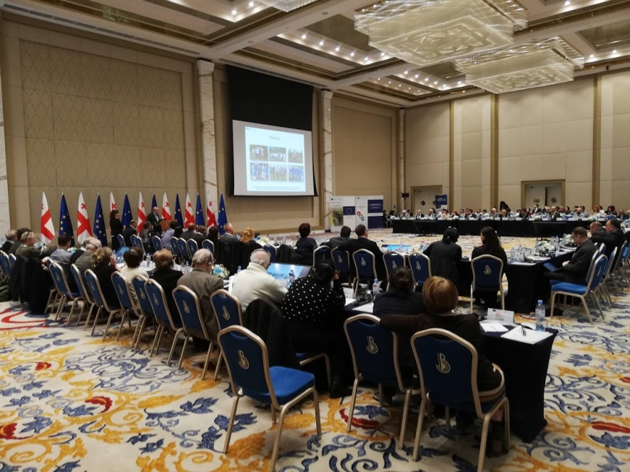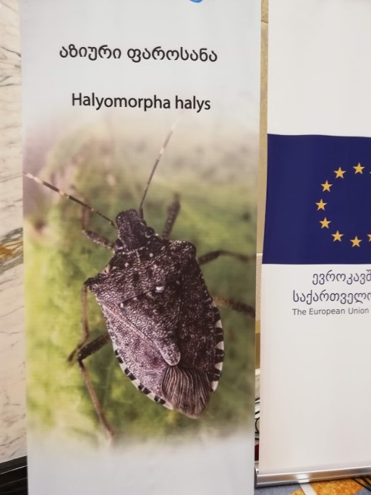

The conference in progress

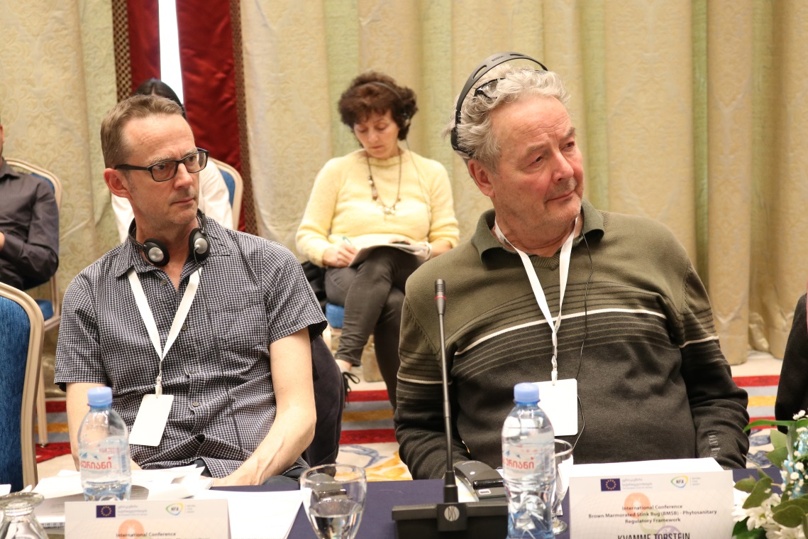

With Norwegian colleague Torstein Kvamme (right) listening to one of the presentations in English (with headphones and live translation available for presentations in Russian and Georgian).