REPORT OF A VISIT TO THE MUSHROOM DAYS EXIBITION, BRABENTHALLEN,
DEN BOSCH NETHERLANDS , 23 May 2019

Ralph Noble, Microbiotech Ltd

Summary
The 35th Mushroom Days exhibition was the largest to date with 87 stands covering all aspects of mushroom cultivation. The emphasis for new developments in this years’ exhibition was labour use efficiency. There were no fully automated or robotic harvesting systems on display although some companies, notably Christiaens and Mycionics, had introduced tilting or moving shelf systems to improve hand picking efficiency and to facilitate the future introduction of robotic harvesting systems. Robotic and semi-automated trimming, grading and packing systems had been developed by several companies. Other new introductions included:
- encapsulated compost supplement to provide slow release nutrition to mushroom mycelium (MCSubstradd)
- liquid casing supplements (Nutrigain and Hydrostor)
- a peat substitute for casing based on corn straw (Cormo)
- a trolley jet washing system for cleaning shelves (Alphie).

Growing Systems and Harvesting Equipment
Two companies, Christieans, Netherlands and Mycionics, Canada (with GTL) demonstrated tilting shelf systems on their stands. Mushrooms are picked with both hands on to a moving belt which takes the mushrooms to an automated trimmer and robotic packing machine. The systems are claimed to increase picking efficiency by more than 4%. The Mycionics system is also claimed to be suitable for a robotic harvesting system. The Christiaens shelf draw system involves pulling the shelves individually to a centralised picking area. This has been constructed at the Hughes Mushroom Farm in Yorkshire.
A semi-automated picking system, which moves along the shelf for pickers to harvest with both hands into ‘grippers’, was displayed by Vandentop (Netherlands).
Automated picking lorries which move along the growing room were on display from several companies including Agro-Projects, ATMO-Control, Dutch Mushroom Equipment, Limbraco, MushComb, Traco (Netherlands), Alphi (Italy) and Growtime and Lucky Grower (Poland).

Mushroom grading and packing
Several companies demonstrated new automated trimming, grading and packing equipment. These can detect and sort under- and over- weight punnets so that mushrooms can easily be transferred to even out weight. Such systems are claimed to save up to 2% in ‘give-away’ product. Systems on display were from Arcon and Viscon (Netherlands), Top Control (Italy) and Mega (Poland). The Arco system can handle up to 100 punnets per minute with a single operator.
Limbraco (Netherlands) have developed a packing robot. The aim is to produce punnets of the correct weight with an even presentation. Mushrooms are packed into punnets with a robot, which uses a laser scanner to check where there is space in partly filled punnets. The mushrooms are then placed into the punnets in a uniform manner. The picker uses both hands to put untrimmed mushrooms on to a moving belt which feeds them to the robot.
The Sherlock Observer displayed by Insort (Austria) is an in-line process control system for removing foreign bodies from food including mushrooms. It is based on near infrared spectroscopy to remove items such as glass, metal, stones, and cardboard from product.

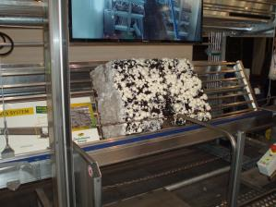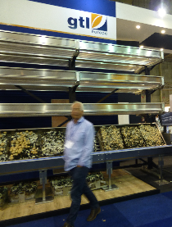
Tilting bed systems from Christiaens (left) and GTL (right)

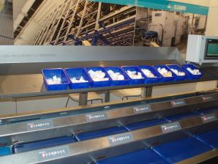
Automated packing line from Arcon
Mushroom Machinery
The majority of the equipment on display was for bunker and tunnel composting systems and the conventional shelf growing system for button (Agaricus) mushrooms. However, equipment is still manufactured for the tray growing system and increasingly for the exotics industry by companies such as MushComb (Netherlands).
A wide range of machinery for mushroom growing and substrate production was on display from companies in several countries. These included the Christiaens, Gicom, GTL Europe, Hoving-Holland, Klaas Zijlstra, MushComb, Top Machinebouw (Netherlands), Alpie, Vierrebi (Italy), Kmach, Ferdlis (China), Growtime, Lucky Grower, The Fillers, Wojtek (Poland). The size of new composting facilities continues to increase, with tunnels now being constructed by Christiaens nearly 50 meters long, requiring compost hoppers 8 m wide.
Equipment for emptying rooms included the MushComb casing separator; at a cost of around £80,000, the economics would depend on the value of the retrieved materials.
Alpie (Italy) demonstrated the first purpose built shelf washer, a trolley system which jet washes the shelves as it moves along.
Netting materials for lining compost tunnels and growing shelves were on display from Comtec, Ten Cate (Netherlands) and Phormium (USA). Mats for Phase I bunkers have been strengthened with ulta high molecular weight polyethylene (UHMWPE).

Climate control and Irrigation
Fancom (Netherlands) has introduced a new climate and watering control computer, the Lumina 765, which has new operating screens to make management of the climate and watering systems easier. The Infinia Remote App enables growers to keep in touch with the conditions on the farm remotely using a smartphone. The system is suitable for the cultivation of button mushrooms and exotics.
Labe-el (Poland) displayed a wide range of environmental monitoring equipment for mushroom climate control, including data loggers, CO₂ meters and thermo-hygrometers.

Mushroom Casing
Casing products on display were conventional blends of black or brown peat, with sugar beet lime or chalk added. These were Harte (Ireland), McDon (Northern Ireland), Sterckx (Belgium), CNC, BVB, Legro (previously Topterra) (Netherlands) and Wokas (Poland). BVB have a new peat substitute, mowed moss, but so far it has only been used in potting media and not casing. A new development in the casing sector is TEFA, a peat substitute developed by Cormo AG (Switzerland) which is based on processed corn straw. Mushroom yields from 50% blends with peat are claimed to be equal with 100% peat based casing.
Hydrostor market K3, a hydrogel which is aimed at improving casing water management.
Mushroom Compost
There were several companies that supply Phase I, II and III compost. These were Hooymans, CNC (Netherlands), Walkro, Coenegrachts, Sterckx (Belgium), Pilzhof (Germany) and Holpol, Gluchowski (Poland). There were no new technical developments in this sector since the 2016 Mushroom Days exhibition. However, many of these companies are now also selling organic Agaricus composts and substrates for exotic mushrooms.

Compost Supplements
Nutrigain markets Organic Gold, an oil and protein based supplement. Amycel, Superchamp, Champfood, Lambert and McSubstradd (Netherlands) provide delayed release protein based supplements for Phase II and III composts. The Eco-Pro Coating supplement from MCSubstradd provides slow release nutrition for the crop. Organic Gold and Champfood Organic are both suitable for organic mushroom cultivation. Nutrigain also markets a casing supplement Organic MycroLiquid, which can be applied to casing during case run, at pinning and post flush. Hydrostor market Folistor, a biostimulator based on ingredients of natural origin which is watered on to the casing. They also market Top Vital Max, which contains various microelements. Champfood and MCSubstradd also provide a compost analysis service based on NIR spectrometry to their customers. The services are also available on a payment per sample basis. These can provide the traditional compost analysis parameters (ash, moisture, pH, N and total volatile nitrogen) and organic matter components (lignin, cellulose and hemicellulose). The analysis can be conducted on both raw materials (straw, chicken and horse manures) and prepared composts.
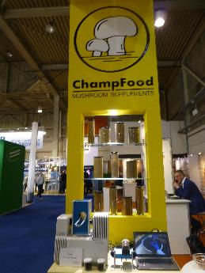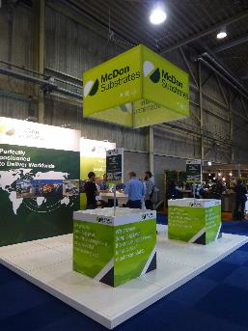
Champfood NIR spectrometry equipment (left) and McDon Substrates stand (right)
Mushroom Spawn and Strains
Mushroom strains are still dominated by Sylvan A15 for whites and Amycel Heirloom for browns although both companies as well several others (Italspawn, Lambert, EuroMycel) had a selection of other white and brown mushroom strains on display. Sylvan markets spawn on conventional rye grain, and Sprint, a smaller particle grain-based product. Amycel produces spawn on rye, millet and a synthetic base (Onyxx).
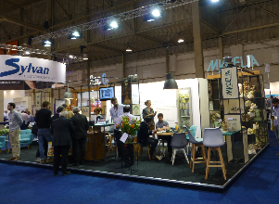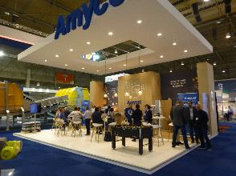
Sylvan and Mycelia stands (left) and Amycel stand (right)

Exotics Substrate and Cultivation
Low energy steam and air autoclaves for the production of exotics substrates were on display from Lagarde (France). The system is claimed to reduce energy and water consumption by 50% compared with conventional hot water autoclaves. Specialist growing rooms and racks for oyster mushroom cultivation are available from MushComb.
Substrates for exotics were on display from BioMycoTec (Germany).
Mushroom spawn for a wide range of exotic mushroom species was on display from Amycel, Sylvan, Eurosubstrat and Mycelia (Belgium),
Sac O₂ (Belgium) and BioMycoTec offer a wide range of culture bags for the sterile culture of spawn and exotic species.

Pest and Disease Control
Mexeo, Poland displayed fogging equipment for applying several types of disinfectant including chlorine dioxide, gluteraldehyde, hydrogen peroxide, and active chlorine.
Nematode products for control of sciarid flies on display were Nemycel from e-nema (Germany) and Nemasys M from BASF/Sylvan.

Mushroom advice and consultancy
A number of companies with stands at the exhibition provide advice and consultancy to the mushroom industry. These include DTO, LTO Vakgroep, Paddenstoelen, Mushroom Office, Mushroom Signal, Mushroom Valley, Delphy, Paddenstoelenpact and ZLTO (Netherlands). Climate Concept (Netherlands) specialises in advice on climate control and energy efficiency in mushrooms buildings. Mushroom production training is provided by the Hogeschool Arnhem Nijmegen (Netherlands).

Research and Development
The Polish Research Institute of Horticulture in Skierniewice is currently conducting research on the influence of casing materials on the occurrence of fungal and bacterial diseases in mushrooms. Utrecht University and the Westerdijk Fungal Biodiversity Institute have been investigating the utilisation of compost by Agaricus. Wageningen University and Research Centre (Netherlands) together with several casing producers have been investigating resistance of mushroom strains to ginger blotch. INAGRO (Belgium) have been investigating the efficacy of different nematode products and application strategies for controlling mushroom sciarids. Asochamp (Spain) has been conducting tests on the casing substituted with TEFA. The ISMS stand had information about the next ISMS Congress in Vancouver, Canada, 2021.

Personal Statement
During this visit I have met with many mushroom researchers, advisers, growers and industry suppliers from around the world. It has provided me with up to date information on the latest developments for labour saving in the mushroom industry.This visit has provided me and my company Microbiotech Ltd with the following opportunities:
- Research and development into new compost and casing supplements
- Comparisons of mushroom casing materials, particularly with regard to disease suppression
- New techniques for measuring mushroom substrate properties
- Opportunities for recycling spent mushroom substrates
- New products for maintaining control of mushroom farm hygiene.

Contact Details
Dr Ralph Noble, Microbiotech Ltd,
Pershore Centre, Avonbank, Pershore, Worcestershire, WR10 3JP, UK
Tel: 03301357199
Email: ralph.noble@microbiotech.co.uk

