**Mapping the African eggplant in urban markets in Tanzania – a visit to TARI and The World Vegetable Center**

30th June – 21st July 2023

Noémie David-Rogeat, University of Nottingham and NIAB

**Headline**

* The African eggplant can be found in every market assessed in both Dar Es Salaam and Arusha.
* The varieties released by the World Vegetable Center (DB3 and TW) are highly popular in the assessed markets.
* The World Vegetable Center is currently expanding - a great opportunity to develop more international and national collaborations.
* The African eggplant has great potential for further research for use as rootstock in tomatoes or brinjal eggplant worldwide.

**Background**

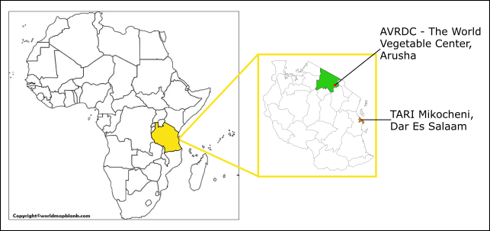In 2018, NIAB received funding from the BBSRC to investigate the role of the African eggplant for smallholder farmers in sub-Saharan Africa (SASSA, Project reference BB/R020655/1). The Tanzania Agricultural Research Institute (TARI) and AVRDC – The World Vegetable Center were both partner organisations involved in the project. The African eggplant (*Solanum aethiopicum*) is an important indigenous crop in sub-Saharan Africa that is liked for its nutrition. It is also highly shade-tolerant, thus prime for inter-cropping for fruit trees such as coconut.

Figure 1 - Maps depicting the location of the visited partners: TARI Mikocheni in Dar Es Salaam and The World Vegetable Center in Arusha.

I started my PhD research on the effects of climate change on the growth and nutritional quality of the African eggplant in 2020. After the travel restrictions of the first few years, I got the opportunity to visit our partners in Tanzania to share the knowledge we all learned through the project. In addition, this visit aimed to complete a mapping of markets in Dar Es Salaam (a coastal city) and Arusha (an in-land city in an agricultural region) to understand the presence and diversity of the African eggplant in these cities. Samples were also collected in Arusha to assess the nutritional quality of the marketed African eggplant.

**Travel findings**

***TARI Mikocheni, Dar Es Salaam***

The first visit of the trip was to TARI Mikocheni in Dar Es Salaam. Dar Es Salaam is a coastal city warm all year round. The city is the most populated in Tanzania with more than 6 million people living there. It is the economic capital of the country with major investments from overseas, mainly China. Coconut is their main crop of interest but they also grow mangoes, oranges, and African eggplant for intercropping.

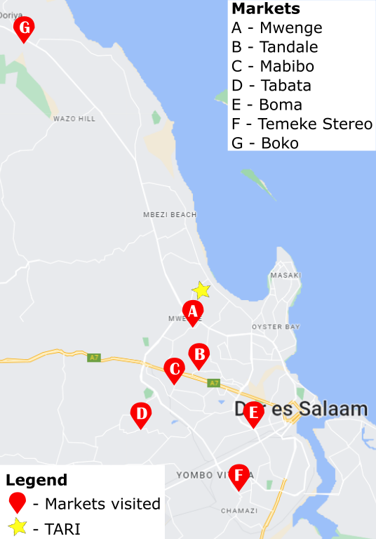I was welcomed to TARI by Violeth Mwaijande who gave me an overview of their work and facilities. TARI’s headquarters are in Dodoma, the capital city of Tanzania, but they have multiple research institutes throughout the country, each focused on a different crop, or crops, based on their location. At Mikocheni, coconut was the main crop of interest. They work in tight collaboration with farmers and frequently visit them to collect samples or data. They also have glasshouses on-site and use them to grow seedlings to share with farmers when ready. They were part of the SASSA project to find a way to control wilt in the African eggplant which is the main drawback for farmers. They are now working on a project involving the African nightshades and amaranth, highlighting how indigenous vegetables are important for the farming sector there.

On the first day, we set up a plan with the driver to visit markets in and around the city for the coming days (Figure 2). The African eggplant was highly popular and found in every market visited. The DB3 cultivar was most commonly found while Tengeru White and other ones were only found in a few markets based on consumers' preferences. The African eggplant was often found with okra as they are often used together while cooking (Figure 3). They were also commonly sold with brinjal eggplant or tomatoes. Unlike tomatoes, however, it was rarely sold on its own.

Figure 2 Map of the visited markets while in Dar Es Salaam and emplacement of TARI Mikocheni.

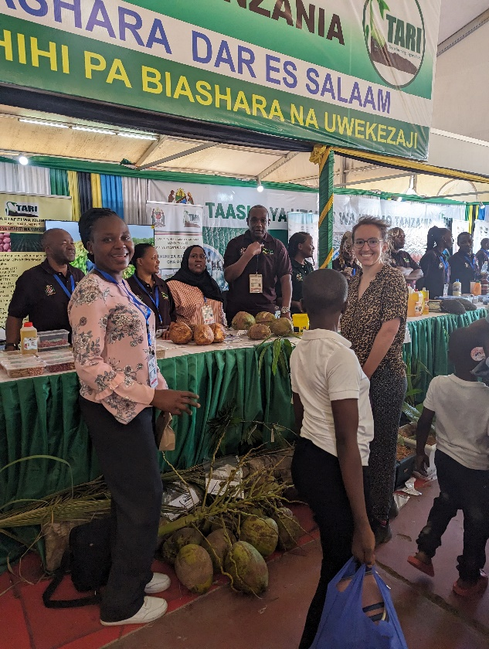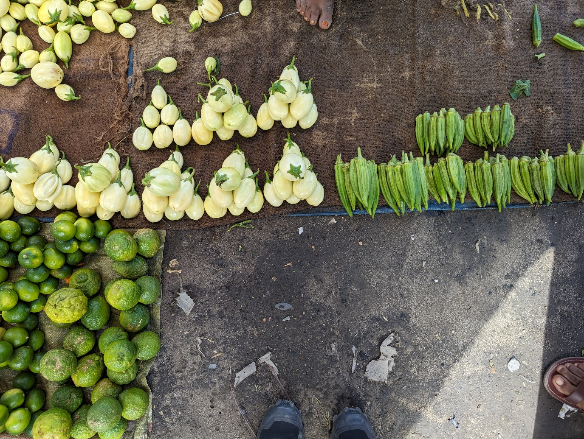The Dar Es Salaam International Trade Fair, also known as Saba Saba, was taking place at the same time as my visit. We decided to visit it on the 7th of July, a public bank holiday to allow people time to visit the fair. TARI was presenting their research to different stakeholders (Figure 4). I got the chance to exchange with researchers working on very exciting projects – from the best way to extract sunflower and palm oil to the chemistry and biology behind their wine-making process.

Figure 3 - Picture of the African eggplant sold alongside okra on a mat on the floor at Boko market.

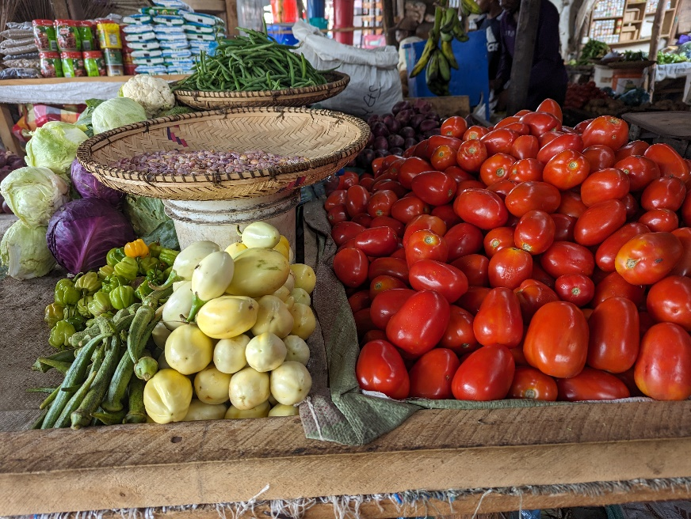

Figure 5 - Display of the African eggplant with other vegetables at Mwenge market.

Figure 4 - Standing in front of the TARI stand with colleagues at the International Trade Fair 2023.

***AVRDC – The World Vegetable Center, Arusha***

The second half of the trip was spent in the North and mountainous region of the country, Arusha (Figure 1). The World Vegetable Center headquarters are in Taiwan and they have regional offices worldwide working on different locally and regionally important crops. As part of the SASSA project, they shared with us the seeds of the African eggplant they developed in-house (DB3 and TW) that we have used for different experiments.

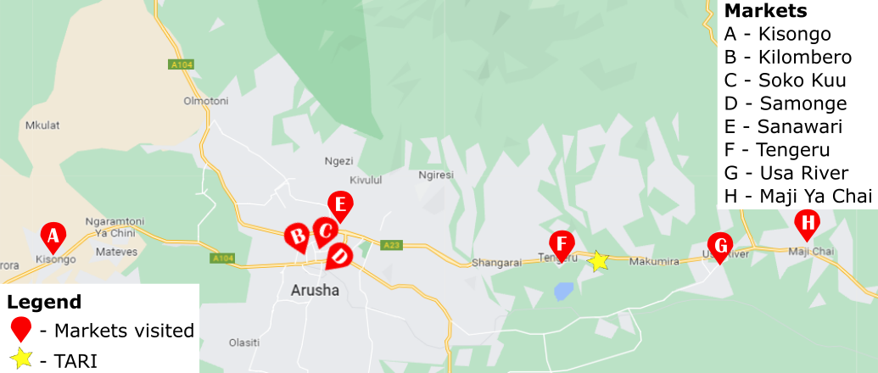On my arrival, I was welcomed by Dr Julia de Bruyn and Zablon Ernest who helped me select markets and set up a plan for when to visit them (Figure 6). Zablon also introduced me to the facilities and their work as split across four areas: breeding, germplasm, food systems, health and diets. They are holding a large genebank which includes numerous African indigenous vegetables and are currently expanding their facilities – an exciting time to be working with them!

Figure 6 - Map of the markets visited markets while in Arusha and emplacement of The World Vegetable Center.

Each day, we visited and mapped markets and collected samples that were put in a fruit dehydrator in their lab (Figure 7). Weekly and permanent markets were visited to gain a better understanding of a wide market landscape. The tomato was the most common crop sold in the markets and the African eggplant, also very common, appeared in the top 5 crops sold for 7 out of the 8 market visited. Similarly to what was observed in Dar Es Salaam, it was most commonly sold alongside okra, tomato, and brinjal eggplant.

Figure 7 - Fruit dehydrator used to dry market samples.

**Personal statement**

**B**

**A**

Figure 8 - The African eggplant fruits collected at the markets. (a) DB3 cultivar and (b) Tengeru White cultivar.

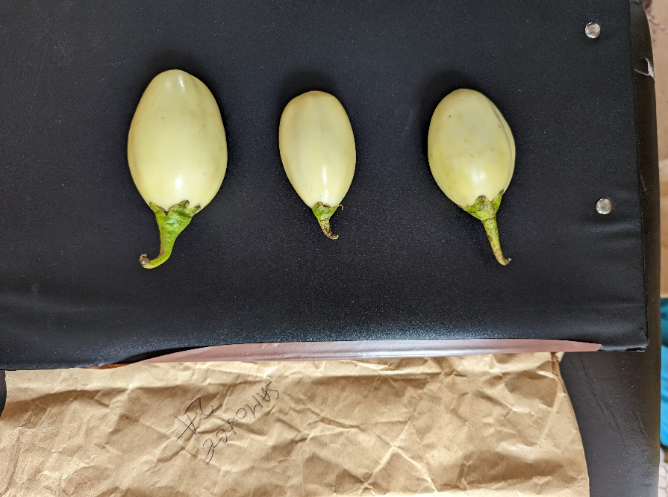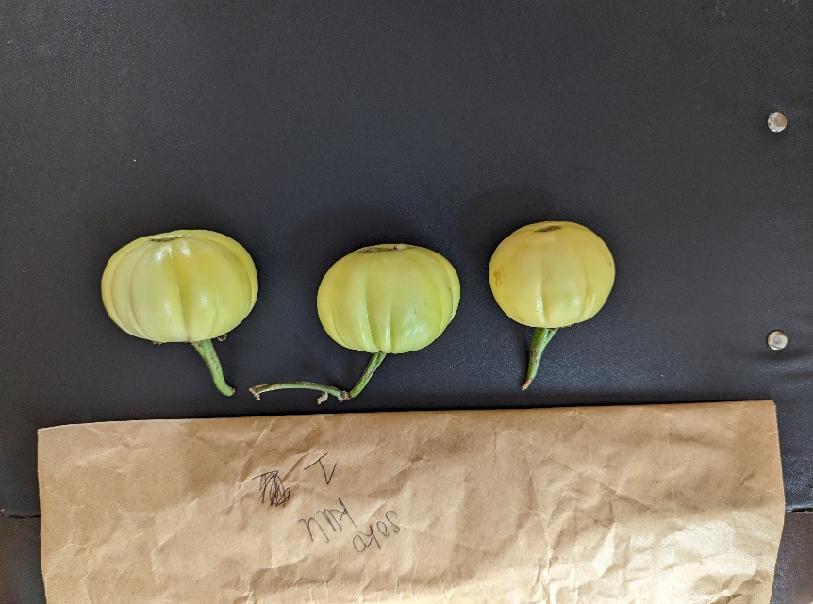

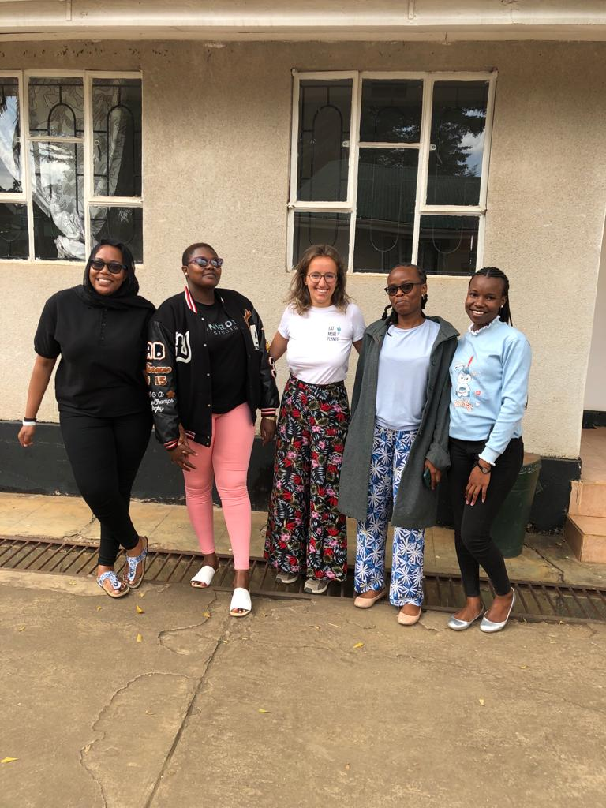Throughout my time in Tanzania, I have gained a better understanding of the African eggplant’s use and popularity in local food systems. This research trip allowed me to meet partners I had only interacted with online, visit their facilities, and understand their motivations. This experience was eye-opening to the range of opportunities for collaboration. The global role of the African eggplant remains largely unexplored and exciting research on its potential for improving related *Solanum* is still to be done. Of particular interest is its potential as tomato rootstock to improve biotic and abiotic stress tolerance, but also its large genetic pool to improve the tolerance of economically important crops through gene editing. International collaboration empowers all involved and should be encouraged to find innovative solutions. I met some incredible and inspiring individuals who I would love to keep working with – maybe a SASSA 2.0?!

Figure 9 - Last day photograph with some colleagues working at The World Vegetable Center.

**Contact details**

Noémie David-Rogeat

PhD Candidate University of Nottingham and NIAB

East Malling

ME19 6BJ

[noemie.david-rogeat@niab.com](mailto:noemie.david-rogeat@niab.com)

**Acknowledgements**

The author would like to thank the following people for making this research travel possible:

* The Glasshouse Crops Research Institute (GCRI) Trust for funding the trip with a Travel Grant.
* The Society of Chemical Industry (SCI) Horticulture group for funding partly the tour with the David Miller Award.
* The Tanzania Agricultural Research Institute (TARI) Mikocheni for welcoming me to Dar Es Salaam and showing me the markets there. A particular thank you to Violeth Mwaijande who accompanied me to each market.
* The World Vegetable Center for Eastern and Southern Africa for allowing me access to their facilities and taking the time to accompany me to the markets. A particular thank you to Zablon Ernest, Fekadu Dinssa, Julia de Bruyn, Upendo Laiser, and Jackie.
* My PhD supervisors, Dr Eleftheria Stavridou and Prof Martin Broadley, for their feedback on the protocol and support.
* BBSRC and NIAB for their funding for my PhD programme through the DTP Nottingham.