Nutrition for growth: 6th Global Micronutrient Forum 2023 – 16th to 20th October 2023
David Fisher, University of Southampton | NIAB East Malling, david.fisher@niab.com
Annabelle Somers, University of Southampton, A.R.Somers@soton.ac.uk
Key points:
- On a global scale, policy makers and relevant stakeholders are increasingly concerned about the nutritional value of our food, and how we can better support growers and consumers to engage with healthy foods.

- Approaches to improving nutrient intakes in target populations were highlighted, including:
  - Biofortification of food
  - Supplementation
  - Genetic modification of foods

- The controlled environments used to grow protected crops in the United Kingdom provide a unique opportunity to create environments that enhance nutritional value, whilst maintaining yield and sustainably controlling pests & disease.

- As the UK government increasingly discusses the importance of nutritious and diverse foods in tackling the multiple emerging public health crises, there will be stronger market forces pushing towards increased nutritional quality in our food.
Background:
In October 2023, David Fisher and Annabelle Somers, PhD students from the South Coast Biosciences Doctoral Training Partnership, attended the Nutrition 4 Growth: 6th Global Micronutrient Forum (MNF) in the Hague, Netherlands. The conference brought together researchers, policy makers, industry, charities, and food system advocates to discuss progress toward micronutrient security in the global food system and to drive forward ideas to overcome the barriers that the global community still face.
The conference covered a diverse range of interventions to improve micronutrient intakes, ranging from “field-based” approaches including biofortification and genetic modification of staple food crops, to “fork-based” approaches where the aim is to encourage positive consumer behaviours and influence policy frameworks. Discussions covered the full breadth of the global food system, highlighting the multitude of methods available to improve the supply and demand for nutritious foods.
Travel findings:
Food and Micronutrient Security are Global Issues
The term “food security” describes “the conditions under which all people, at all times, have access to sufficient, nutritious, and culturally appropriate food to support an active and healthy lifestyle” (WFP, 2021). As its name suggests, micronutrient security is a branch of food security, focused on understanding and safeguarding people’s access to sufficient dietary micronutrients.
 | Name (bold indicates where >10% of UK adult males are not meeting the RNI) | Daily RNI for a UK adult male | Example plant sources
Vitamins | Vitamin A | 700 ug | Broccoli, carrot, pumpkin, spinach, sweet potato
 | The Vitamin B Complex (B1, B2, B3, B6, B9, B12) | 0.9 mg, 1.3 mg, 16 mg, 1.4 mg, 200 ug, 1.5 ug | Spinach, broccoli, parsnip, asparagus, bananas, peas
 | Vitamin C | 40 mg | Sweet peppers, strawberries, blackcurrants, broccoli, brussel sprouts, potatoes, parsnips
 | Vitamin D | 10 ug | Mushrooms
Minerals | Calcium | 700 mg | Soybeans, blackberry, kiwi, apricot, broccoli, spinach
 | Phosphorus | 550 mg | Lentils, hazelnuts, sunflower and pumpkin seeds, sweetcorn, bananas, oranges
 | Magnesium | 300 mg | Avocado, edamame beans, spinach, acorn squash, kale, bananas, artichokes
 | Sodium | 1600 mg | Apples, bananas, pears, celery, spinach, carrots, beetroot
 | Potassium | 3500 mg | Butternut squash, potatoes, spinach, broccoli, parsnip
 | Chloride | 2500 mg | Rye, seaweed, tomatoes, lettuce, celery
 | Iron | 8.7 mg | Spinach, mushrooms, beans, peas, tomatoes, legumes, kale, leeks
 | Zinc | 9.5 mg | Soybean, peas, sweetcorn, blackcurrants, strawberries, blackberries
 | Copper | 1.2 mg | Cashews, sesame seeds, spinach, sweet potato, mushrooms
 | Selenium | 75 ug | Brazil nuts, haricot beans, sunflower seeds, oats, spinach, mushrooms, banana
 | Iodine | 140 ug | Potatoes, bananas, strawberries, cranberries, green beans
RNI – recommended nutrient intake.
Consumption of sufficient micronutrients is vital for maintaining good mental and physical health. Over 30 years ago, the World Health Organisation (WHO) estimated more than 2 billion people worldwide were suffering from micronutrient deficiencies. More recent evidence suggests that this number is even higher. Additionally, we now understand that micronutrient deficiencies are not just a problem for developing countries; North American and European countries are also severely affected. For example, despite ample supply of micronutrient dense foods in the UK, widespread financial and time poverty have resulted in modern diets becoming inexpensive and convenient: these diets are rich in calories, but largely devoid of micronutrients as a result. Therefore, the UK has one of the highest levels of micronutrient insecurity in Europe.
The role of the UK horticultural sector in improving access to micronutrient-dense foods
The UK horticulture industry has primarily focused on ways of increasing yields and sensory quality in fruits and vegetables, and so very little resource has been directed toward understanding and promoting the adoption of more nutrient dense cultivars and nutrition-smart growing practices. Particularly interesting to the UK horticulture industry were discussions on the genetic and agroecological efforts to enhance the nutritional content of crops. One of the authors (Annabelle Somers) is researching variation in the Vitamin B content of different parsnip cultivars and breeding selections and has identified a 4-fold difference between the lowest and highest vitamin content. By promoting and utilising nutrient-dense varieties, a simple 1-for-1 substitution could prove an effective intervention for improving micronutrient intakes in the UK. With the UK having recently relaxed the regulations around R&D using genetically modified crops, the time and resources needed to bring new, nutrient-dense cultivars to market could be drastically reduced, further boosting the viability of a cultivar-substitution strategy.
Protected crops provide a unique opportunity to manipulate the growing environment to improve their nutrient content, otherwise known as biofortification. One of the authors (David Fisher) is researching the impact of foliar mineral sprays on the nutritional quality, sensory quality, and yield of commercial UK strawberry varieties. Improving our understanding of the relationships between agronomic inputs and nutritional outputs will enable the UK horticulture industry to optimise future growing practices for high nutritional yields without compromising productivity and grower profit margins.
Improved production must be paired with greater demand to justify the resources needed to put nutrition-smart horticulture into practice.
There is little incentive to produce more nutritious food if people will not buy and eat it, nor is there reason for growers to produce more nutritious food if it is not profitable for their businesses. Therefore, the approaches outlined above need to be paired with approaches and practices that encourage consumers to purchase more fruit and vegetables, and/or reward growers for the nutritional quality of their crops.
Discussions at the Micronutrient Forum highlighted an array of approaches for increasing demand for nutrient dense foods. Interestingly, there is much better knowledge of micronutrient deficiencies in the Global South compared to the Developed North where micronutrient deficiencies can be harder to detect. As a result, great progress has been made toward researching and tackling micronutrient deficiencies in Africa and Southeast Asia, relative to progress made in the UK. However, the importance of healthy food has become increasingly topical in the UK with the Cost-of-Living crisis and Free School Meals being covered extensively in the media. The UK would be wise to learn from the work being carried out in the global south, and to use the findings to help to inform strategies to tackle UK micronutrient insecurities. Through advocacy, increasing political willpower, and better nutrition surveillance programmes, approaches and devices can be put in place to support consumers in purchasing nutrient dense foods, with knock-on effects to support growers in efforts to produce the most micronutrient dense foods possible.
Personal statements
David and Annabelle both presented posters at the MNF, showcasing their work on UK vitamin C security and UK folate security, and the ways in which British-grown strawberries and parsnips could be leveraged to help people to consume more of these key micronutrients. David showcased his work toward identifying strawberry cultivars with superior vitamin C content, the working hypothesis being that a theoretically simple 1:1 substitution of a cultivar with lower vitamin C content with a vitamin C-dense cultivar could improve nationwide vitamin C security during the UK summer.
David:
Listening to the discussions on crop biofortification efforts in different parts of the world re-affirmed to me what a great opportunity we have with protected crops in the UK to make a positive difference to the nutritional value of local fruit and vegetable. I have observed in my work on strawberries more than 2-fold variation in fruit vitamin C content. For context, that is the difference between an average 80-gram portion of strawberries providing ~50% of the EU’s recommended daily intake, to ~105% in an 80-gram portion. Understanding, utilising, and promoting more nutrient dense cultivars could make a big difference to the UK’s micronutrient security as a result.
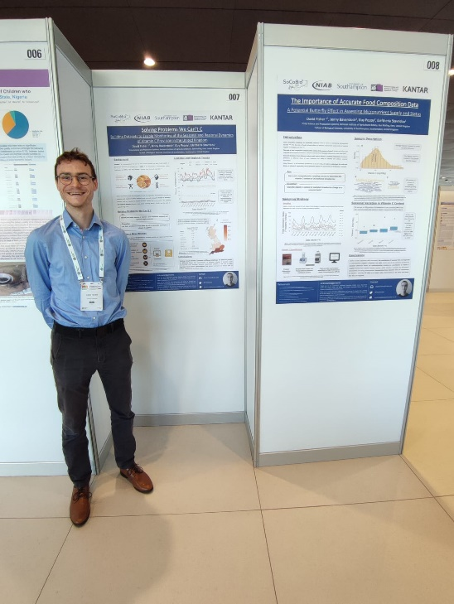
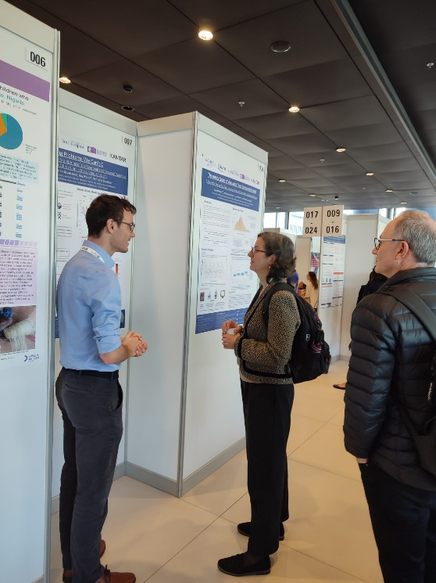
In the UK’s modern polytunnels and glasshouses, growers also have a higher-than-ever degree of control over their crops’ environments. A very interesting discussion centred around the fact that more nutrient-dense cultivars can only sustain a higher-than-average nutritional content if they are supplied with enough micronutrients in their fertiliser inputs. The issues associated with over-use of inorganic fertilisers are well documented. Developing more environmentally friendly ways of producing the fertilisers needed by our protected crops, and the efficiency with which we supply these nutrients, will be key to unlocking the full potential of biofortified fruit and vegetables in the UK.
Annabelle presented her work on the prevalence of folate deficiencies in the UK population, and how we can use locally-grown crops such as parsnips to address these deficiencies. So far, Annabelle’s research has highlighted that an estimated 16% of teenage girls are clinically deficient in vitamin B9, illustrating the importance of developing and implementing new ways by which micronutrient intakes in the UK could be improved. Annabelle also presented her findings on the scale of genetic variation in parsnip vitamin B9 content, and the potential for combining more nutritious cultivar selection with free school meal programmes to deliver ample micronutrients to school-age children without any additional costs to parents and carers. Again, increasing the utilisation of folate-dense cultivars and educating politicians, businesses, and the public as to the nutritional value of locally-grown foods is likely to be an effective way of increasing micronutrient intakes across the UK population.
Annabelle:
My favourite aspect of the Micronutrient Forum was learning about the wealth and quality of work on food security that is undertaken in the Global South by not-for-profit groups. There is much we can learn from our colleagues abroad about growing better food and helping people to eat good food too!
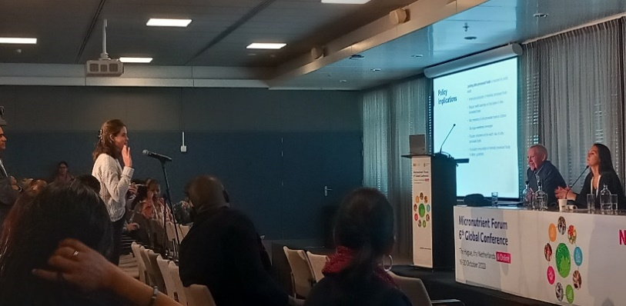
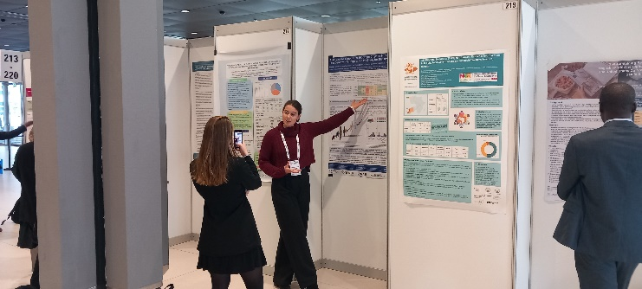
Many of the people I work with are of the opinion that food security is not a problem we face in the UK, as we have supermarkets stocked with ample fruit and vegetables to support our health. I should confess that I too was of this opinion when I started my research. However, diet related disease is one of the greatest causes of death and disability in the UK, despite being entirely preventable. The MNF 2023 showcased to me frameworks that other countries have used to promote micronutrient intakes, and I am looking forward to taking what I have learnt and applying it to the UK food system.
Overall, the MNF 2023 was an eye-opening and inspiring event, and our participation has generated new research and outreach ideas, new collaborations, and has renewed enthusiasm for the tasks at hand. A big thank you from the authors to the GCRI trust for the generous funding that made the trip possible!

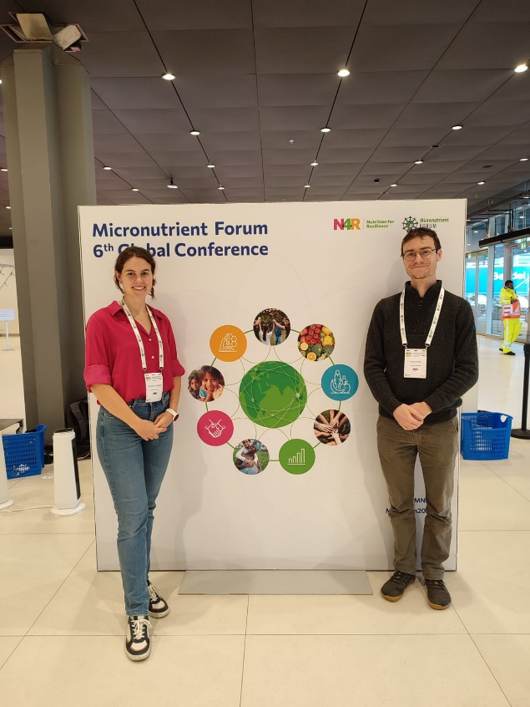

We also thank BBSRC for the generous funding of our Doctoral studies, the SoCoBio DTP for their support and provision of training opportunities, NIAB at East Malling, the National Resource Institute, and the University of Southampton for use of their facilities, equipment and resources, our collaborators at Kantar Worldpanel and Tozer seeds, and our supervision team, Prof. Guy Poppy (University of Southampton), Dr Jenny Baverstock (University of Southampton), and Dr Eleftheria Stavridou (NIAB). Our great experiences at the 2023 MNF would not have been possible without their support.

